# LISTING PROGRAM

1. **Index.php**

<?php

include_once("setup/config.php");

?>

<!DOCTYPE html>

<html lang="en">

<head>

<title><?= title() ?></title>

<link rel="icon" href="<?= base_url('images/logo.png') ?>">

<meta charset="UTF-8">

<meta name="author" content="Farh">

<meta http-equiv="X-UA-Compatible" content="IE=Edge">

<meta name="viewport" content="width=device-width, initial-scale=1, maximum-scale=1">

<meta name="keywords" content="Tempat Penyedia Layanan Bot Line, bot line, line, bot, tempat, penyedia, layanan, online, terpercaya, line ranger, line cookie run, line messenger, line messaging api, api line, downlad, aplikasi line, line bot, self bot, defense bot line, full, mod, apk, indonesia">

<meta name="description" content="Penyedia Layanan Bot Line Pertama dan Terpercaya" />

<meta name="robots" content="index, follow, max-snippet:-1, max-image-preview:large, max-video-preview:-1" />

<link rel="canonical" href="<?= base_url('') ?>" />

<meta property="og:locale" content="en_US" />

<meta property="og:type" content="website" />

<meta property="og:title" content="<?= title() ?>" />

<meta property="og:description" content="Website Tempat Penyedia Layanan Bot Line Terbaik dan Terpercaya di Indonesia 2020. Buat bot mu sendiri dnegan mudah." />

<meta property="og:url" content="<?= base_url('') ?>" />

<meta property="og:site_name" content="<?= title() ?>" />

<meta property="og:image" content="<?= base_url('images/logo.png') ?>" />

<meta property="og:image:width" content="1110" />

<meta property="og:image:height" content="592" />

<meta name="twitter:label1" content="Website">

<meta name="twitter:data1" content="Penyedia Layanan Bot Line">

<link rel="stylesheet" href="<?= base_url('assets/css/bootstrap.min.css') ?>">

<!-- <link rel="stylesheet" href="css/font-awesome.min.css"> -->

<link rel="stylesheet" href="<?= base_url('assets/vendor/fontawesome-free/css/all.min.css') ?>" type="text/css">

<link rel="stylesheet" href="<?= base_url('assets/css/aos.css') ?>">

<link rel="stylesheet" href="<?= base_url('assets/css/owl.carousel.min.css') ?>">

<link rel="stylesheet" href="<?= base_url('assets/css/owl.theme.default.min.css') ?>">

<!-- MAIN CSS -->

<link rel="stylesheet" href="<?= base_url('assets/css/templatemo-digital-trend.css') ?>">

<?php

include_once('components/analytics.php');

?>

</head>

<body>

<!-- Google Tag Manager (noscript) -->

<noscript><iframe src="https://www.googletagmanager.com/ns.html?id=GTM-WGSZQHM"

height="0" width="0" style="display:none;visibility:hidden"></iframe></noscript>

<!-- End Google Tag Manager (noscript) -->

<?php

include_once('components/tagmanager.php');

include_once('components/navbar.php');

?>

<!-- HERO -->

<section class="hero hero-bg d-flex justify-content-center align-items-center">

<div class="container">

<div class="row">

<div class="col-lg-6 col-md-10 col-12 d-flex flex-column justify-content-center align-items-center">

<div class="hero-text">

<h1 class="text-white" data-aos="fade-up">Line bot service providers</h1>

<a href="<?= base_url('register.php') ?>" class="custom-btn btn-bg btn mt-3" data-aos="fade-up" data-aos-delay="100">Register Now!</a>

<!-- <strong class="d-block py-3 pl-5 text-white" data-aos="fade-up" data-aos-delay="200"><i class="fa fa-phone mr-2"></i> +99 080 070 4224</strong> -->

</div>

</div>

<div class="col-lg-6 col-12">

<div class="hero-image" data-aos="fade-up" data-aos-delay="300">

<img src="<?= base_url('media/work.svg') ?>" class="img-fluid" alt="working girl">

</div>

</div>

</div>

</div>

</section>

<!-- ABOUT -->

<section class="about section-padding pb-0" id="about">

<div class="container">

<div class="row">

<div class="col-lg-7 mx-auto col-md-10 col-12">

<!--<div class="about-info">-->

<!-- <h2 class="mb-4" data-aos="fade-up">Messaging API overview</h2>-->

<!-- <p class="mb-0" data-aos="fade-up">Use the Messaging API to build bots that provide personalized experiences for your users on LINE.-->

<!-- <br><br>You associate your bot with a channel on the LINE Platform. The bot works behind the LINE Official Account that is generated when you create the channel if you operate the account in bot mode.</p>-->

<!--</div>-->

<div class="about-info">

<h2 class="mb-4" data-aos="fade-up">Bot Bot My ID overview</h2>

<h3 class="mb-0 text-muted" data-aos="fade-up"><a href="<?= base_url() ?>">Bot Bot My ID</a> Merupakan sebuah pengelola Bot LINE Messenger berbasis website yang dapat digunakan secara gratis kapanpun dan dimanapun.

<br><br>

<a href="<?= base_url() ?>">Bot Bot My ID</a> dapat mengelola pesan terjadwal, keyword, user, group, dan room.

</h3>

</div>

<div class="about-image" data-aos="fade-up" data-aos-delay="200">

<img src="<?= base_url('media/connection.png') ?>" class="img-fluid" alt="office">

</div>

</div>

</div>

</div>

</section>

<!-- PROJECT -->

<section class="project section-padding" id="featured">

<div class="container-fluid">

<div class="row">

<div class="col-lg-12 col-12">

<h2 class="mb-5 text-center" data-aos="fade-up">

Please take a look through our

<strong>featured</strong>

</h2>

<div class="owl-carousel owl-theme" id="project-slide">

<div class="item project-wrapper" data-aos="fade-up">

<div style="max-height: 750px; overflow: hidden;">

<img src="<?= base_url('images/fitur/fitur1.png') ?>" class="img-fluid" alt="project image" style="max-width: initial;">

</div>

<div class="project-info">

<small></small>

<h3>

<a href="project-detail.html">

<span>Interact With Bot</span>

<i class="fa fa-angle-right project-icon"></i>

</a>

</h3>

</div>

</div>

<div class="item project-wrapper" data-aos="fade-up">

<div style="max-height: 750px; overflow: hidden;">

<img src="<?= base_url('images/fitur/fitur2.png') ?>" class="img-fluid" alt="project image" style="max-width: initial;">

</div>

<div class="project-info">

<small></small>

<h3>

<a href="project-detail.html">

<span>Make Your Own Notes</span>

<i class="fa fa-angle-right project-icon"></i>

</a>

</h3>

</div>

</div>

<div class="item project-wrapper" data-aos="fade-up">

<div style="max-height: 750px; overflow: hidden;">

<img src="<?= base_url('images/fitur/fitur3.png') ?>" class="img-fluid" alt="project image" style="max-width: initial;">

</div>

<div class="project-info">

<small></small>

<h3>

<a href="project-detail.html">

<span>Make Your Schedule</span>

<i class="fa fa-angle-right project-icon"></i>

</a>

</h3>

</div>

</div>

<!-- Create Your Keywords, Manage Your Bot -->

</div>

</div>

</div>

</div>

</section>

<!--testimonial-->

<section class="testimonial section-padding">

<div id="testimonial" class="carousel slide" data-ride="carousel" data-interval="3000">

<div class="carousel-inner">

<?php

$testi = array(

array(

"Mikhael",

"L",

"Berkat website ini jadwal saya menjadi teratur dan saya tidak pernah terlambat dikarenakan adanya pengingat yang benar benar di butuhkan saat mengalami jadwal yang padat"

),

array(

"Afif",

"L",

"Berkat website ini memudahkan saya untuk membuat bot tanpa susah payah lagi, dengan banyaknya fitur yang diberikan pada bot ini membuat kegiatan saya lebih produktif terimakasih boboboy eh botbot.my.id"

),

array(

"Annisa",

"P",

"Keren sih dan berguna bgt remindernya. apalagi sekarang di zaman sibuk2 dan beberapa org lupa tugas yang dimilikinya. aplikasi ini berguna bgt utk mahasiswa. ada jadwal matkulnya, apalagi tugass waahh ini sangat amat membantu, pengingat ujian wkkw, dan pengingat adzan serta puasa."

),

array(

"Hanif",

"L",

"Mantap si ini, cocok banget buat mahasiswa bikin jadwal biar teratur, apa lagi yang kerjaannya padet"

)

);

shuffle($testi);

$first = true;

foreach ($testi as $testimoni) {

?>

<div class="carousel-item<?= $first == true ? ' active' : '' ?>">

<div class="container">

<div class="row">

<div class="col-lg-6 col-md-5 col-12">

<div class="contact-image" data-aos="fade-up">

<img src="images/<?= $testimoni[1] == 'P' ? 'female-avatar.png' : 'male-avatar.png' ?>" class="img-fluid" alt="website">

</div>

</div>

<div class="col-lg-6 col-md-7 col-12">

<h4 class="my-5 pt-3" data-aos="fade-up" data-aos-delay="100">Client Testimonials</h4>

<div class="quote" data-aos="fade-up" data-aos-delay="200"></div>

<h2 class="mb-4" data-aos="fade-up" data-aos-delay="300"><?= $testimoni[2] ?></h2>

<p data-aos="fade-up" data-aos-delay="400">

<strong><?= $testimoni[0] ?></strong>

<span class="mx-1"></span>

<small></small>

</p>

</div>

</div>

</div>

</div>

<?php

$first = false;

}

?>

</div>

<a class="carousel-control-prev" href="#testimonial" role="button" data-slide="prev"></a>

<a class="carousel-control-next" href="#testimonial" role="button" data-slide="next"></a>

</div>

</section>

<?php

include_once('components/footer.php');

?>

<!-- SCRIPTS -->

<script src="<?= base_url('assets/js/jquery.min.js') ?>"></script>

<script src="<?= base_url('assets/js/bootstrap.min.js') ?>"></script>

<script src="<?= base_url('assets/js/aos.js') ?>"></script>

<script src="<?= base_url('assets/js/owl.carousel.min.js') ?>"></script>

<script src="<?= base_url('assets/js/smoothscroll.js') ?>"></script>

<script src="<?= base_url('assets/js/custom.js') ?>"></script>

<?php

include_once("components/tawkto.php");

?>

</body>

</html>

Download Formatting took: 585 msPHP Formatter made by Spark Labs

Copyright Gerben van Veenendaal

{"mode":"full","isActive":false}

1. **Register.php**

<?php

include_once("setup/config.php");

require_once "PHPMailer/PHPMailer.php";

require_once "PHPMailer/Exception.php";

require_once "PHPMailer/OAuth.php";

require_once "PHPMailer/POP3.php";

require_once "PHPMailer/SMTP.php";

use PHPMailer\PHPMailer\PHPMailer;

use PHPMailer\PHPMailer\Exception;

function send_email($email, $email_name, $host, $username, $password, $from_name, $subject, $content, $alt_body)

{

$mail = new PHPMailer;

$mail->SMTPDebug = 0;

$mail->isSMTP();

$mail->Host = $host;

$mail->SMTPAuth = true;

$mail->Username = $username;

$mail->Password = $password;

$mail->SMTPSecure = "ssl";

$mail->Port = 465;

$mail->From = $username;

$mail->FromName = $from_name;

$mail->addAddress($email, $email_name);

$mail->isHTML(true);

$mail->Subject = $subject;

$mail->Body = $content;

$mail->AltBody = $alt_body;

if (!$mail->send()) {

return "Mailer Error: " . $mail->ErrorInfo;

} else {

return "Message has been sent successfully";

}

}

$err = $succes = "";

if (isset($_POST['submit'], $_POST['nama'], $_POST['username'], $_POST['email'], $_POST['password'], $_POST['confirm_password'])) {

if (empty($_POST['submit']) || empty($_POST['nama']) || empty($_POST['username']) || empty($_POST['email']) || empty($_POST['password']) || empty($_POST['confirm_password'])) {

$err = '';

} else {

if ($_POST['password'] == $_POST['confirm_password']) {

$nama = mysqli_real_escape_string($conn, ucwords(strtolower($_POST['nama'])));

$username = mysqli_real_escape_string($conn, strtolower($_POST['username']));

$email = mysqli_real_escape_string($conn, strtolower($_POST['email']));

$password = mysqli_real_escape_string($conn, md5($_POST['password']));

$uniqid = uniqid();

$timestamp = date("Y-m-d H:i:s");

$uuid = generate_uuid();

if ($stmt = $conn->prepare('SELECT username_acc, password_acc FROM tb_account WHERE username_acc = ?')) {

$stmt->bind_param('s', $username);

$stmt->execute();

$stmt->store_result();

if ($stmt->num_rows > 0) {

$err = 'Username exists, please choose another!';

} else {

if ($stmt = $conn->prepare('SELECT email_acc, password_acc FROM tb_account WHERE email_acc = ?')) {

$stmt->bind_param('s', $email);

$stmt->execute();

$stmt->store_result();

if ($stmt->num_rows > 0) {

$err = 'Email exists, please choose another!';

} else {

if ($stmt = $conn->prepare('INSERT INTO tb_account (`uuid_acc`, `nama_acc`, `username_acc`, `password_acc`, `email_acc`, `activation_code`, `timestamp`, `last_update`) VALUES (?, ?, ?, ?, ?, ?, ?, ?)')) {

$password = password_hash($password, PASSWORD_DEFAULT);

$stmt->bind_param('ssssssss', $uuid, $nama, $username, $password, $email, $uniqid, $timestamp, $timestamp);

$stmt->execute();

$from = from_email();

$subject = 'Account Activation Required';

$headers = 'From: ' . $from . "\r\n" . 'Reply-To: ' . $from . "\r\n" . 'X-Mailer: PHP/' . phpversion() . "\r\n" . 'MIME-Version: 1.0' . "\r\n" . 'Content-Type: text/html; charset=UTF-8' . "\r\n";

$activate_link = base_url() . 'activate.php?email=' . $email . '&code=' . $uniqid;

$message = '<p>Please click the following link to activate your account: <a href="' . $activate_link . '">' . $activate_link . '</a></p>';

send_email($email, $nama, "mail.botbot.my.id", "support@botbot.my.id", "", "Support Bot Bot My ID", $subject, $message, "");

$succes = 'Please check your email to activate your account!';

} else {

$err = 'Could not prepare statement!';

}

}

} else {

$err = 'Err! Contact Admin!';

}

}

$stmt->close();

} else {

$err = 'Err! Contact Admin!';

}

} else {

$err = 'Could not prepare statement!';

}

$conn->close();

}

}

?>

<!DOCTYPE html>

<html lang="en">

<head>

<title><?= title() ?> - Register</title>

<link rel="icon" href="<?= base_url('images/logo.png') ?>">

<meta charset="UTF-8">

<meta name="author" content="<?= author() ?>">

<meta http-equiv="X-UA-Compatible" content="IE=Edge">

<meta name="viewport" content="width=device-width, initial-scale=1, maximum-scale=1">

<meta name="keywords" content="Register <?= title() ?>">

<meta name="description" content="Register <?= title() ?>" />

<meta name="robots" content="index, follow, max-snippet:-1, max-image-preview:large, max-video-preview:-1" />

<link rel="canonical" href="<?= base_url('register.php') ?>" />

<meta property="og:locale" content="en_US" />

<meta property="og:type" content="website" />

<meta property="og:title" content="<?= title() ?>" />

<meta property="og:description" content="Register <?= title() ?>" />

<meta property="og:url" content="<?= base_url('register.php') ?>'" />

<meta property="og:site_name" content="Bot Bot My ID" />

<meta property="article:publisher" content="<?= base_url('register.php') ?>'" />

<meta property="article:published_time" content="2020-11-19T00:00:00+00:00" />

<meta property="article:modified_time" content="2020-11-19T00:00:00+00:00" />

<meta property="og:image" content="<?= base_url('images/logo.png') ?>'" />

<meta property="og:image:width" content="1110" />

<meta property="og:image:height" content="592" />

<meta name="twitter:label1" content="Written by">

<meta name="twitter:data1" content="Farh">

<meta name="twitter:label2" content="website">

<meta name="twitter:data2" content="Register <?= title() ?>">

<!-- Custom fonts for this template-->

<link href="<?= base_url('assets/vendor/fontawesome-free/css/all.min.css') ?>" rel="stylesheet" type="text/css">

<link href="https://fonts.googleapis.com/css?family=Nunito:200,200i,300,300i,400,400i,600,600i,700,700i,800,800i,900,900i" rel="stylesheet">

<!-- Custom styles for this template-->

<link href="<?= base_url('assets/css/sb-admin-2.min.css') ?>" rel="stylesheet">

<?php

include_once('components/analytics.php');

?>

</head>

<body class="bg-gradient-primary">

<div class="container">

<div class="card o-hidden border-0 shadow-lg my-5">

<div class="card-body p-0">

<!-- Nested Row within Card Body -->

<div class="row">

<div class="col-lg-12">

<div class="p-5">

<div class="text-center">

<h1 class="h4 text-gray-900 mb-4">Create an Account!</h1>

</div>

<?php

if (isset($err) && !empty($err)) {

echo 'div class="alert alert-danger alert-dismissible fade show" role="alert">

' . $err . '

<button type="button" class="close" data-dismiss="alert" aria-label="Close">

<span aria-hidden="true">&times;</span>

</button>

</div>';

} elseif (isset($succes) && !empty($succes)) {

echo '<div class="alert alert-success alert-dismissible fade show" role="alert">

' . $succes . '

<button type="button" class="close" data-dismiss="alert" aria-label="Close">

<span aria-hidden="true">&times;</span>

</button>

</div>';

}

?>

<form action="" method="POST" class="user" onsubmit="return confirm('Continue?');" >

<div class="form-group">

<label for="">Name</label>

<input type="text" class="form-control form-control-user" id="" placeholder="Name" name="nama" maxlength="30" required>

</div>

<div class="form-group">

<label for="">Username</label>

<input type="text" class="form-control form-control-user" id="" placeholder="Username" name="username" maxlength="30" required>

</div>

<div class="form-group">

<label for="">Email</label>

<input type="email" class="form-control form-control-user" id="" placeholder="Email Address" name="email" maxlength="50" required>

</div>

<div class="form-group row">

<div class="col-sm-6 mb-3 mb-sm-0">

<label for="">Password</label>

<!--<input type="password" onkeyup='check();' class="form-control form-control-user" id="password" placeholder="Password" name="password" required>-->

<input type="password" onkeyup='' class="form-control form-control-user" id="password" placeholder="Password" name="password" maxlength="70" required>

</div>

<div class="col-sm-6">

<label for="">Repeat Password</label>

<input type="password" onkeyup='check();' class="form-control form-control-user" id="confirm_password" placeholder="Repeat Password" name="confirm_password" maxlength="70" required>

<label id='message'></label>

</div>

</div>

<!-- <button type="submit" class="btn btn-primary btn-user btn-block">Register Account<button> -->

<button id="submit" type="submit" name="submit" value="

_oke" class="btn btn-primary btn-user btn-block" disabled>Register Account</button>

<!--<hr>-->

<!--<a href="#" class="btn btn-google btn-user btn-block">-->

<!-- <i class="fab fa-google fa-fw"></i> Register with Google-->

<!--</a>-->

</form>

<hr>

<div class="text-center">

<a class="small" href="forgot-password.php">Forgot Password?</a>

</div>

<div class="text-center">

<a class="small" href="login.php">Already have an account? Login!</a>

</div>

</div>

</div>

</div>

</div>

</div>

</div>

<!-- Bootstrap core JavaScript-->

<script src="<?= base_url('assets/vendor/jquery/jquery.min.js') ?>"></script>

<script src="<?= base_url('assets/vendor/bootstrap/js/bootstrap.bundle.min.js') ?>"></script>

<!-- Core plugin JavaScript-->

<script src="<?= base_url('assets/vendor/jquery-easing/jquery.easing.min.js') ?>"></script>

<!-- Custom scripts for all pages-->

<script src="<?= base_url('assets/js/sb-admin-2.min.js') ?>"></script>

<script>

var check = function() {

if (document.getElementById('password').value ==

document.getElementById('confirm_password').value) {

document.getElementById('message').innerHTML = '';

document.getElementById('submit').disabled = false;

} else {

document.getElementById('message').style.color = 'red';

document.getElementById('message').innerHTML = 'Password not matching';

document.getElementById('submit').disabled = true;

}

}

</script>

<?php

include_once('components/tawkto.php');

?>

</body>

</html>

1. **Login.php**

<?php

include_once("setup/config.php");

if (isset($_SESSION["loggedin"]) && $_SESSION["loggedin"] === true) {

header("location: dashboard/?page=dashboard");

exit;

}

$err = $succes = "";

if (isset($_POST['username'], $_POST['password'], $_POST['submit'])) {

if ($stmt = $con->prepare('SELECT uuid_acc, nama_acc, password_acc, activation_code FROM tb_account WHERE username_acc = ?')) {

$usr = mysqli_real_escape_string($con, strtolower($_POST['username']));

$pwd = mysqli_real_escape_string($con, md5($_POST['password']));

$stmt->bind_param('s', $usr);

$stmt->execute();

$stmt->store_result();

if ($stmt->num_rows > 0) {

$stmt->bind_result($uuid, $nama, $password, $code);

$stmt->fetch();

if (password_verify($pwd, $password)) {

if ($code == 'activated') {

session_regenerate_id();

$_SESSION['loggedin'] = TRUE;

$_SESSION['name'] = $nama;

$_SESSION['username'] = $usr;

$_SESSION['uuid'] = $uuid;

header("location: dashboard/?p=dashboard");

exit();

} else {

$err = 'Verify your email!';

}

} else {

$err = 'Incorrect username or password!';

}

} else {

$err = 'Incorrect username or password!';

}

$stmt->close();

} else {

$err = 'Err! Contact Admin!';

}

}

?>

<!DOCTYPE html>

<html lang="en">

<head>

<meta charset="utf-8">

<link rel="icon" href="<?= base_url('images/logo.png') ?>">

<meta http-equiv="X-UA-Compatible" content="IE=edge">

<meta name="viewport" content="width=device-width, initial-scale=1, shrink-to-fit=no">

<meta name="description" content="">

<meta name="author" content="<?= author() ?>">

<title><?= title() ?> - Login</title>

<!-- Custom fonts for this template-->

<link href="<?= base_url('assets/css/all.min.css" rel="stylesheet') ?>" type="text/css">

<link href="https://fonts.googleapis.com/css?family=Nunito:200,200i,300,300i,400,400i,600,600i,700,700i,800,800i,900,900i" rel="stylesheet">

<!-- Custom styles for this template-->

<link href="<?= base_url('assets/css/sb-admin-2.min.css') ?>" rel="stylesheet">

<?php

include_once('components/analytics.php');

?>

</head>

<body class="bg-gradient-primary">

<div class="container">

<!-- Outer Row -->

<div class="row justify-content-center">

<div class="col-xl-10 col-lg-12 col-md-9">

<div class="card o-hidden border-0 shadow-lg my-5">

<div class="card-body p-0">

<!-- Nested Row within Card Body -->

<div class="row">

<div class="col-lg-12">

<div class="p-5">

<div class="text-center">

<h1 class="h4 text-gray-900 mb-4">Login</h1>

</div>

<?php

if (isset($err) && !empty($err)) {

echo '<div class="alert alert-danger alert-dismissible fade show" role="alert">

' . $err . '

<button type="button" class="close" data-dismiss="alert" aria-label="Close"> <span aria-hidden="true">&times;</span>

</button>

</div>';

} elseif (isset($succes) && !empty($succes)) {

echo '<div class="alert alert-success alert-dismissible fade show" role="alert">

' . $succes . '

<button type="button" class="close" data-dismiss="alert" aria-label="Close">

<span aria-hidden="true">&times;</span>

</button> </div>';

}

?>

<form action="" method="POST" class="user">

<div class="form-group">

<label for="">Username</label>

<input type="text" name="username" class="form-control form-control-user" id="usernane" placeholder="Username" required>

</div>

<div class="form-group">

<label for="">Password</label>

<input type="password" name="password" class="form-control form-control-user" id="password" placeholder="Password" required>

</div>

<div class="form-group">

<div class="custom-control custom-checkbox small">

<input type="checkbox" class="custom-control-input" id="customCheck">

<label class="custom-control-label" for="customCheck">Remember Me</label>

</div>

</div>

<button type="submit" name="submit" value="_oke" class="btn btn-primary btn-user btn-block">

Login

</button>

<!--<hr>-->

<!--<a href="#" class="btn btn-google btn-user btn-block">-->

<!-- <i class="fab fa-google fa-fw"></i> Login with Google-->

<!--</a>-->

</form>

<hr>

<div class="text-center">

<a class="small" href="forgot-password.php">Forgot Password?</a>

</div>

<div class="text-center">

<a class="small" href="register.php">Create an Account!</a>

</div>

</div>

</div>

</div>

</div>

</div>

</div>

</div>

</div>

<!-- Bootstrap core JavaScript-->

<script src="<?= base_url('assets/vendor/jquery/jquery.min.js') ?>"></script>

<script src="<?= base_url('assets/vendor/bootstrap/js/bootstrap.bundle.min.js') ?>"></script>

<!-- Core plugin JavaScript-->

<script src="<?= base_url('assets/vendor/jquery-easing/jquery.easing.min.js') ?>"></script>

<!-- Custom scripts for all pages-->

<script src="<?= base_url('assets/js/sb-admin-2.min.js') ?>"></script>

<?php

include_once('components/tawkto.php');

?>

</body>

</html>

1. **Forgot-password.php**

<?php

include_once("setup/config.php");

require_once "PHPMailer/PHPMailer.php";

require_once "PHPMailer/Exception.php";

require_once "PHPMailer/OAuth.php";

require_once "PHPMailer/POP3.php";

require_once "PHPMailer/SMTP.php";

use PHPMailer\PHPMailer\PHPMailer;

use PHPMailer\PHPMailer\Exception;

function send_email($email, $email_name, $host, $username, $password, $from_name, $subject, $content, $alt_body)

{

$mail = new PHPMailer;

$mail->SMTPDebug = 0;

$mail->isSMTP();

$mail->Host = $host;

$mail->SMTPAuth = true;

$mail->Username = $username;

$mail->Password = $password;

$mail->SMTPSecure = "ssl";

$mail->Port = 465;

$mail->From = $username;

$mail->FromName = $from_name;

$mail->addAddress($email, $email_name);

$mail->isHTML(true);

$mail->Subject = $subject;

$mail->Body = $content;

$mail->AltBody = $alt_body;

if (!$mail->send()) {

return "Mailer Error: " . $mail->ErrorInfo;

} else {

return "Message has been sent successfully";

}

}

if (isset($_GET['reset'], $_GET['email']) && !empty($_GET['reset']) && !empty($_GET['email'])) {

$kode = mysqli_real_escape_string($conn, ucwords(strtolower($_GET['reset'])));

$email = mysqli_real_escape_string($conn, ucwords(strtolower($_GET['email'])));

if ($stmt = $conn->prepare('SELECT password_acc FROM tb_account WHERE email_acc = ?')) {

$stmt->bind_param('s', $email);

$stmt->execute();

$stmt->store_result();

if ($stmt->num_rows > 0) {

$stmt->bind_result($password);

$stmt->fetch();

$pass = ucwords(strtolower(md5(md5($password))));

if ($kode === $pass) {

$success = "bener";

} else {

$err = 'Invalid username or code';

}

} else {

$err = 'Invalid username or code';

}

} else {

$err = 'Err! Contact Admin!(1)';

}

}

if (isset($_POST['submit']) && !empty($_POST['submit'])) {

if ($_POST['submit'] == 'submit') {

$email = mysqli_real_escape_string($conn, ucwords(strtolower($_POST['email'])));

if ($stmt = $conn->prepare('SELECT email_acc, password_acc FROM tb_account WHERE email_acc = ?')) {

$stmt->bind_param('s', $email);

$stmt->execute();

$stmt->store_result();

if ($stmt->num_rows > 0) {

$stmt->bind_result($email, $password);

$stmt->fetch();

$pass = ucwords(strtolower(md5(md5($password))));

$from = from_email();

$subject = 'Account Reset Password';

$headers = 'From: ' . $from . "\r\n" . 'Reply-To: ' . $from . "\r\n" . 'X-Mailer: PHP/' . phpversion() . "\r\n" . 'MIME-Version: 1.0' . "\r\n" . 'Content-Type: text/html; charset=UTF-8' . "\r\n";

$reset_link = base_url() . 'forgot-password.php?email=' . $email . '&reset=' . $pass;

$message = '<p>Please click the following link to reset your password: <a href="' . $reset_link . '">' . $reset_link . '</a></p>';

send_email($email, $email, "mail.botbot.my.id", "support@botbot.my.id", "", "Support Bot Bot My ID", $subject, $message, "");

$msg = 'Please check your email to reset your password!';

} else {

$err = 'Invalid email';

}

} else {

$err = 'Err! Contact Admin!(2)';

}

} else if ($_POST['submit'] == 'update') {

$new_password = mysqli_real_escape_string($conn, md5($_POST['new_password']));

$kode_cek = mysqli_real_escape_string($conn, ucwords(strtolower($_POST['kode'])));

$email_cek = mysqli_real_escape_string($conn, ucwords(strtolower($_POST['email_cek'])));

if ($stmt = $conn->prepare('SELECT password_acc FROM tb_account WHERE email_acc = ?')) {

$stmt->bind_param('s', $email_cek);

$stmt->execute();

$stmt->store_result();

if ($stmt->num_rows > 0) {

$stmt->bind_result($password);

$stmt->fetch();

$pass_cek = ucwords(strtolower(md5(md5($password))));

if ($kode_cek === $pass_cek) {

$new_pass = password_hash($new_password, PASSWORD_DEFAULT);

if ($upt = $conn->prepare('UPDATE `tb_account` SET `password_acc` = ?,`last_update` = ? WHERE email_acc = ?')) {

$upt->bind_param('sss', $new_pass, $now, $email_cek);

if ($upt->execute()) {

$msg = "Password berhasil diubah!";

} else {

$err = 'Err! Contact Admin!1';

}

} else {

$err = 'Err! Contact Admin!2';

}

} else {

$err = 'Invalid username or code';

}

} else {

$err = 'Invalid username or code';

}

} else {

$err = 'Err! Contact Admin!(3)';

}

}

}

?>

<!DOCTYPE html>

<html lang="en">

<head>

<meta charset="utf-8">

<link rel="icon" href="<?= base_url('images/logo.png') ?>">

<meta http-equiv="X-UA-Compatible" content="IE=edge">

<meta name="viewport" content="width=device-width, initial-scale=1, shrink-to-fit=no">

<meta name="description" content="">

<meta name="author" content="<?= author() ?>">

<title><?= title() ?>- Forgot Password</title>

<!-- Custom fonts for this template-->

<link href="<?= base_url('assets/vendor/fontawesome-free/css/all.min.css') ?>" rel="stylesheet" type="text/css">

<link href="https://fonts.googleapis.com/css?family=Nunito:200,200i,300,300i,400,400i,600,600i,700,700i,800,800i,900,900i" rel="stylesheet">

<!-- Custom styles for this template-->

<link href="<?= base_url('assets/css/sb-admin-2.min.css') ?>" rel="stylesheet">

<!-- Global site tag (gtag.js) - Google Analytics -->

<script async src="https://www.googletagmanager.com/gtag/js?id=G-X9NBS58GFL"></script>

<script>

window.dataLayer = window.dataLayer || [];

function gtag(){dataLayer.push(arguments);}

gtag('js', new Date());

gtag('config', 'G-X9NBS58GFL');

</script>

</head>

<body class="bg-gradient-primary">

<div class="container">

<!-- Outer Row -->

<div class="row justify-content-center">

<div class="col-xl-10 col-lg-12 col-md-9">

<div class="card o-hidden border-0 shadow-lg my-5">

<div class="card-body p-0">

<!-- Nested Row within Card Body -->

<div class="row">

<div class="col-lg-12">

<div class="p-5">

<div class="text-center">

<h1 class="h4 text-gray-900 mb-2">Forgot Your Password?</h1>

<?php

if (!isset($success) && $success != "bener") {

?>

<p class="mb-4">We get it, stuff happens. Just enter your email address below and we'll send you a link to reset your password!</p>

<?php

}

?>

</div>

<?php

if (isset($err) && !empty($err)) {

echo '<div class="alert alert-danger alert-dismissible fade show" role="alert">

' . $err . '

<button type="button" class="close" data-dismiss="alert" aria-label="Close">

<span aria-hidden="true">&times;</span>

</button>

</div>';

} elseif (isset($msg) && !empty($msg)) {

echo ' <div class="alert alert-success alert-dismissible fade show" role="alert">

' . $msg . '

<button type="button" class="close" data-dismiss="alert" aria-label="Close">

<span aria-hidden="true">&times;</span>

</button>

</div>';

}

?>

<form action="<?= base_url('forgot-password.php') ?>" method="POST" class="user">

<div class="form-group">

<?php

if (isset($success) && $success == "bener") {

?>

<input type="hidden" name="email_cek" value="<?= $email ?>">

<input type="hidden" name="kode" value="<?= $pass ?>">

<label for="">New Password</label>

<input type="password" onkeyup='' class="form-control form-control-user" id="password" placeholder="New Password" name="new_password" required>

<label for="">Repeat Password</label>

<input type="password" onkeyup='check();' class="form-control form-control-user" id="confirm_password" placeholder="Repeat Password" name="confirm_password" required>

<label id='message'></label>

<?php

} else {

?>

<label for="">Email</label>

<input type="email" name="email" class="form-control form-control-user" id="" aria-describedby="emailHelp" placeholder="Enter Email Address..." required>

<?php

}

?>

</div>

<button type="submit" name="submit" value="<?= isset($success) && $success == "bener" ? 'update' : 'submit' ?>" class="btn btn-primary btn-user btn-block">Reset Password</button>

</form>

<hr>

<div class="text-center">

<a class="small" href="register.php">Create an Account!</a>

</div>

<div class="text-center">

<a class="small" href="login.php">Already have an account? Login!</a>

</div>

</div>

</div>

</div>

</div>

</div>

</div>

</div>

</div>

<!-- Bootstrap core JavaScript-->

<script src="<?= base_url('assets/vendor/jquery/jquery.min.js') ?>"></script>

<script src="<?= base_url('assets/vendor/bootstrap/js/bootstrap.bundle.min.js') ?>"></script>

<!-- Core plugin JavaScript-->

<script src="<?= base_url('assets/vendor/jquery-easing/jquery.easing.min.js') ?>"></script>

<!-- Custom scripts for all pages-->

<script src="<?= base_url('assets/js/sb-admin-2.min.js') ?>"></script>

<script>

var check = function() {

if (document.getElementById('password').value ==

document.getElementById('confirm_password').value) {

document.getElementById('message').innerHTML = '';

document.getElementById('submit').disabled = false;

} else {

document.getElementById('message').style.color = 'red';

document.getElementById('message').innerHTML = 'Password not matching';

document.getElementById('submit').disabled = true;

}

}

</script>

</body>

</html>

1. **Contact.php**

<?php

include_once("setup/config.php");

require_once "PHPMailer/PHPMailer.php";

require_once "PHPMailer/Exception.php";

require_once "PHPMailer/OAuth.php";

require_once "PHPMailer/POP3.php";

require_once "PHPMailer/SMTP.php";

use PHPMailer\PHPMailer\PHPMailer;

use PHPMailer\PHPMailer\Exception;

function send_email($email, $email_name, $host, $username, $password, $from_name, $subject, $content, $alt_body)

{

$mail = new PHPMailer;

$mail->SMTPDebug = 0;

$mail->isSMTP();

$mail->Host = $host;

$mail->SMTPAuth = true;

$mail->Username = $username;

$mail->Password = $password;

$mail->SMTPSecure = "ssl";

$mail->Port = 465;

$mail->From = $username;

$mail->FromName = $from_name;

$mail->addAddress($email, $email_name);

$mail->isHTML(true);

$mail->Subject = $subject;

$mail->Body = $content;

$mail->AltBody = $alt_body;

if (!$mail->send()) {

return "Mailer Error: " . $mail->ErrorInfo;

} else {

return "Message has been sent successfully";

}

}

if (isset($_POST['submit']) && $_POST['submit'] == "_oke") {

$nama = mysqli_real_escape_string($conn, htmlspecialchars($_POST['name']));

$email = mysqli_real_escape_string($conn, htmlspecialchars($_POST['email']));

$message = mysqli_real_escape_string($conn, htmlspecialchars($_POST['message']));

$uuid_contact = mysqli_real_escape_string($conn, generate_uuid());

$query = "INSERT INTO `tb_contact`(`uuid_contact`, `name`, `email`, `message`, `timestamp`) VALUES ('$uuid_contact', '$nama', '$email', '$message', '$now')";

if (mysqli_query($conn, $query)) {

$suskes = "Terima kasih sudah menghubungi kami!";

} else {

$err = "Err!";

}

$from = from_email();

$subject = 'Hello Contact!';

$headers = 'From: ' . $from . "\r\n" . 'Reply-To: ' . $from . "\r\n" . 'X-Mailer: PHP/' . phpversion() . "\r\n" . 'MIME-Version: 1.0' . "\r\n" . 'Content-Type: text/html; charset=UTF-8' . "\r\n";

$message = '<p><b>Ada yang kirim pesan!<br><br>

From: </b>' . $nama . '<br><br>

<b>Email: </b>' . $email . '<br><br>

<b>Message: </b><br>' . $message . '<br><br>

</p>';

send_email("farhsubs@gmail.com", $nama, "mail.botbot.my.id", "support@botbot.my.id", "", "Support Bot Bot My ID", $subject, $message, "");

$succes = 'Please check your email to activate your account!';

}

?>

<!DOCTYPE html>

<html lang="en">

<head>

<title><?= title() ?></title>

<link rel="icon" href="<?= base_url('images/logo.png') ?>">

<meta charset="UTF-8">

<meta name="author" content="Farh">

<meta http-equiv="X-UA-Compatible" content="IE=Edge">

<meta name="viewport" content="width=device-width, initial-scale=1, maximum-scale=1">

<meta name="keywords" content="Tempat Penyedia Layanan Bot Line, bot line, line, bot, tempat, penyedia, layanan, online, terpercaya, line ranger, line cookie run, line messenger, line messaging api, api line, downlad, aplikasi line, line bot, self bot, defense bot line, full, mod, apk, indonesia">

<meta name="description" content="Penyedia Layanan Bot Line Pertama dan Terpercaya" />

<meta name="robots" content="index, follow, max-snippet:-1, max-image-preview:large, max-video-preview:-1" />

<link rel="canonical" href="<?= base_url('') ?>" />

<meta property="og:locale" content="en_US" />

<meta property="og:type" content="website" />

<meta property="og:title" content="<?= title() ?>" />

<meta property="og:description" content="Website Tempat Penyedia Layanan Bot Line Terbaik dan Terpercaya di Indonesia 2020. Buat bot mu sendiri dnegan mudah." />

<meta property="og:url" content="<?= base_url('') ?>" />

<meta property="og:site_name" content="<?= title() ?>" />

<meta property="og:image" content="<?= base_url('images/logo.png') ?>" />

<meta property="og:image:width" content="1110" />

<meta property="og:image:height" content="592" />

<meta name="twitter:label1" content="Website">

<meta name="twitter:data1" content="Penyedia Layanan Bot Line">

<link rel="stylesheet" href="<?= base_url('assets/css/bootstrap.min.css') ?>">

<!-- <link rel="stylesheet" href="css/font-awesome.min.css"> -->

<link rel="stylesheet" href="<?= base_url('assets/vendor/fontawesome-free/css/all.min.css') ?>" type="text/css">

<link rel="stylesheet" href="<?= base_url('assets/css/aos.css') ?>">

<link rel="stylesheet" href="<?= base_url('assets/css/owl.carousel.min.css') ?>">

<link rel="stylesheet" href="<?= base_url('assets/css/owl.theme.default.min.css') ?>">

<!-- MAIN CSS -->

<link rel="stylesheet" href="<?= base_url('assets/css/templatemo-digital-trend.css') ?>">

<?php

include_once('components/analytics.php');

?>

</head>

<body>

<?php

include_once('components/tagmanager.php');

include_once('components/navbar.php');

?>

<!-- CONTACT -->

<section class="contact section-padding">

<div class="container">

<div class="row">

<div class="col-lg-6 mx-auto col-md-7 col-12 py-5 mt-5 text-center" data-aos="fade-up">

<h1 class="mb-4">Hey there, Let's <strong>talk</strong> about <strong>creative</strong> projects</h1>

<p>or email us at <a href="mailto:hello@botbot.my.id">hello@botbot.my.id</a> / <a href="mailto:botbot.my.id@gmail.com">botbot.my.id@gmail.com</a></p>

</div>

<div class="col-lg-8 mx-auto col-md-10 col-12">

<form action="" method="POST" class="contact-form" data-aos="fade-up" data-aos-delay="300" role="form">

<div class="row">

<div class="col-lg-6 col-12">

<input type="text" class="form-control" name="name" placeholder="Name">

</div>

<div class="col-lg-6 col-12">

<input type="email" class="form-control" name="email" placeholder="Email">

</div>

<div class="col-lg-12 col-12">

<textarea class="form-control" rows="6" name="message" placeholder="Message"></textarea>

</div>

<div class="col-lg-5 mx-auto col-7">

<button type="submit" class="form-control" id="submit-button" name="submit" value="_oke">Send Message</button>

</div>

</div>

</form>

</div>

</div>

</div>

</section>

<?php

include_once('components/footer.php');

?>

<!-- SCRIPTS -->

<script src="<?= base_url('assets/js/jquery.min.js') ?>"></script>

<script src="<?= base_url('assets/js/bootstrap.min.js') ?>"></script>

<script src="<?= base_url('assets/js/aos.js') ?>"></script>

<script src="<?= base_url('assets/js/owl.carousel.min.js') ?>"></script>

<script src="<?= base_url('assets/js/smoothscroll.js') ?>"></script>

<script src="<?= base_url('assets/js/custom.js') ?>"></script>

<?php

include_once('components/tawkto.php');

?>

</body>

</html>

1. **Dashborad.php**

<?php

if (isset($_POST['submit']) && $_POST['submit'] == "_oke") {

if (empty($_POST['secretkey']) || empty($_POST['channelaccesstoken']) || empty($uuid)) {

$err = "Err!";

} else {

$sk = mysqli_real_escape_string($conn, $_POST['secretkey']);

$cat = mysqli_real_escape_string($conn, $_POST['channelaccesstoken']);

$r = mysqli_query($conn, "SELECT uuid_acc FROM bot_setting WHERE uuid_acc='$uuid'");

$cek = mysqli_num_rows($r);

if ($cek > 0) {

$query = "UPDATE `bot_setting` SET `channel_secret`='$sk',`channel_access_token`='$cat',`last_update`='$now' WHERE uuid_acc='$uuid'";

$secretkey = $sk;

$channelaccesstoken = $cat;

} else {

$query = "INSERT INTO `bot_setting`(`uuid_acc`, `channel_secret`, `channel_access_token`, `timestamp`, `last_update`) VALUES ('$uuid','$sk','$cat','$now','$now')";

$secretkey = $sk;

$channelaccesstoken = $cat;

}

if (mysqli_query($conn, $query)) {

$succes = "Berhasil di update!";

} else {

$err = "Err!";

}

}

}

$tot_keyword = mysqli_num_rows(mysqli_query($conn, "SELECT `uuid_word` FROM `bot_word` WHERE uuid_acc='$uuid_acc'"));

$tot_jadwal = mysqli_num_rows(mysqli_query($conn, "SELECT `uuid_jadwal` FROM `bot_jadwal` WHERE uuid_acc='$uuid_acc'"));

$tot_grid = mysqli_num_rows(mysqli_query($conn, "SELECT `uuid_group` FROM `bot_group` WHERE uuid_acc='$uuid_acc'"));

$tot_user = mysqli_num_rows(mysqli_query($conn, "SELECT `uuid_user` FROM `bot_user` WHERE uuid_acc='$uuid_acc'"));

?>

<!-- Begin Page Content -->

<div class="container-fluid">

<!-- Page Heading -->

<div class="d-sm-flex align-items-center justify-content-between mb-4">

<h1 class="h3 mb-0 text-gray-800">Dashboard</h1>

</div>

<!-- Content Row -->

<div class="row">

<!-- Total Keyword -->

<div class="col-xl-3 col-md-6 mb-4">

<div class="card border-left-primary shadow h-100 py-2">

<div class="card-body">

<div class="row no-gutters align-items-center">

<div class="col mr-2">

<div class="text-xs font-weight-bold text-primary text-uppercase mb-1">Total Keyword</div>

<div class="h5 mb-0 font-weight-bold text-gray-800"><?= $tot_keyword ?></div>

</div>

<div class="col-auto">

<i class="fas fa-puzzle-piece fa-2x text-gray-300"></i>

</div>

</div>

</div>

</div>

</div>

<!-- Total Jadwal -->

<div class="col-xl-3 col-md-6 mb-4">

<div class="card border-left-success shadow h-100 py-2">

<div class="card-body">

<div class="row no-gutters align-items-center">

<div class="col mr-2">

<div class="text-xs font-weight-bold text-success text-uppercase mb-1">Total Jadwal</div>

<div class="h5 mb-0 font-weight-bold text-gray-800"><?= $tot_jadwal ?></div>

</div>

<div class="col-auto">

<i class="far fa-calendar-alt fa-2x text-gray-300"></i>

</div>

</div>

</div>

</div>

</div>

<!-- Total Group -->

<div class="col-xl-3 col-md-6 mb-4">

<div class="card border-left-info shadow h-100 py-2">

<div class="card-body">

<div class="row no-gutters align-items-center">

<div class="col mr-2">

<div class="text-xs font-weight-bold text-info text-uppercase mb-1">Total Group/Room</div>

<div class="h5 mb-0 font-weight-bold text-gray-800"><?= $tot_grid ?></div>

</div>

<div class="col-auto">

<i class="fas fa-comments fa-2x text-gray-300"></i>

</div>

</div>

</div>

</div>

</div>

<!-- Total User -->

<div class="col-xl-3 col-md-6 mb-4">

<div class="card border-left-warning shadow h-100 py-2">

<div class="card-body">

<div class="row no-gutters align-items-center">

<div class="col mr-2">

<div class="text-xs font-weight-bold text-warning text-uppercase mb-1">Total User</div>

<div class="h5 mb-0 font-weight-bold text-gray-800"><?= $tot_user ?></div>

</div>

<div class="col-auto">

<i class="fas fa-user fa-2x text-gray-300"></i>

</div>

</div>

</div>

</div>

</div>

</div>

<div class="row">

<div class="col-lg-12">

<!--Carousel Wrapper-->

<div id="multi-item-example" class="carousel slide carousel-multi-item" data-ride="carousel">

<div class="text-center">

<div class="align-items-center">

<div class="controls-top" style="padding-bottom: 20px;">

<a class="btn-floating" href="#multi-item-example" data-slide="prev"><i class="fas fa-chevron-left fa-2x" style="padding-right: 25px;"></i></a>

<a class="btn-floating" href="#multi-item-example" data-slide="next"><i class="fas fa-chevron-right fa-2x" style="padding-left: 25px; text-align:right;"></i></a>

</div>

</div>

</div>

<!--Slides-->

<div class="carousel-inner" role="listbox">

<!--First slide-->

<div class="carousel-item active">

<div class="col-md-12">

<div class="card shadow mb-4">

<!-- Card Header - Accordion -->

<a href="#collapseCardExample" class="d-block card-header py-3" data-toggle="collapse" role="button" aria-expanded="true" aria-controls="collapseCardExample">

<h6 class="m-0 font-weight-bold text-danger">1. Update Your Setting</h6>

</a>

<!-- Card Content - Collapse -->

<div class="collapse show" id="collapseCardExample">

<div class="card-body">

<div class="text-center">

<img class="img-fluid px-3 px-sm-4 mt-3 mb-4" style="width: 25rem;" src="<?= base_url('media/input.png') ?>" alt="">

</div>

<form action="" method="POST">

<div class="form-group">

<input type="hidden" name="" value="">

<label for="kata">Secret Key</label>

<div class="input-group">

<input type="password" class="form-control sk" id="kata" name="secretkey" placeholder="771e1776ff2f5102cda18..." value="<?= $secretkey ?>" maxlength="50">

<span class="input-group-btn">

<button class="btn btn-default revealsk" type="button" ><i class="fas fa-eye-slash"></i></button>

</span>

</div>

</div>

<div class="form-group">

<label for="respon">Channel Access Token</label>

<div class="input-group">

<input type="password" class="form-control cat" id="kata" name="channelaccesstoken" placeholder="8+F2KKK/mxrXhVRaVz8IdZ/7S7KTVQ7usf3Ubzr1hFseywh..." value="<?= $channelaccesstoken ?>" maxlength="200">

<span class="input-group-btn">

<button class="btn btn-default revealcat" type="button"><i class="fas fa-eye-slash"></i></button>

</span>

</div>

</div>

<button type="submit" name="submit" value="_oke" class="btn btn-primary">Update</button>

<!-- Button trigger modal -->

<!-- <button type="button" class="btn btn-primary" data-toggle="modal" data-target="#tskcat">?</button> -->

</form>

</div>

</div>

</div>

</div>

</div>

<!--/.First slide-->

<!--Second slide-->

<div class="carousel-item">

<div class="col-md-12">

<div class="card shadow mb-4">

<!-- Card Header - Accordion -->

<a href="#collapseCardExample" class="d-block card-header py-3" data-toggle="collapse" role="button" aria-expanded="true" aria-controls="collapseCardExample">

<h6 class="m-0 font-weight-bold text-danger">2. Add URL Webhook</h6>

</a>

<!-- Card Content - Collapse -->

<div class="collapse show" id="collapseCardExample">

<div class="card-body">

<div class="text-center">

<img class="img-fluid px-3 px-sm-4 mt-3 mb-4" style="width: 25rem;" src="<?= base_url('media/setting.png') ?>" alt="">

</div>

Ubah Webhook URL dengan alamat:

<br><br>

<h5><b><?= base_url('api/webhook/' . $uuid) ?></b></h5>

<br>

<!-- <button type="button" class="btn btn-primary" data-toggle="modal" data-target="#tskcat">?</button> -->

</div>

</div>

</div>

</div>

</div>

<!--/.Second slide-->

<!--Third slide-->

<div class="carousel-item">

<div class="col-md-12">

<div class="card shadow mb-4">

<!-- Card Header - Accordion -->

<a href="#collapseCardExample" class="d-block card-header py-3" data-toggle="collapse" role="button" aria-expanded="true" aria-controls="collapseCardExample">

<h6 class="m-0 font-weight-bold text-danger">3. Kelola BOT Kamu</h6>

</a>

<!-- Card Content - Collapse -->

<div class="collapse show" id="collapseCardExample">

<div class="card-body">

<div class="text-center">

<img class="img-fluid px-3 px-sm-4 mt-3 mb-4" style="width: 25rem;" src="<?= base_url('media/welcome.png') ?>" alt="">

</div>

<p>Selamat BOT kamu sudah dapat digunakan ^^</p>

</div>

</div>

</div>

</div>

</div>

<!--/.Third slide-->

</div>

<!--/.Slides-->

</div>

</div>

</div>

</div>

<!-- /.container-fluid -->

<!-- Modal -->

<div class="modal fade" id="tskcat" tabindex="-1" role="dialog" aria-labelledby="Tutorial SK & CAT" aria-hidden="true">

<div class="modal-dialog modal-lg" role="document">

<div class="modal-content">

<div class="modal-header">

<h5 class="modal-title" id="exampleModalLongTitle">Cara Mendapatkan Secret Key & Channel Access Token</h5>

<button type="button" class="close" data-dismiss="modal" aria-label="Close">

<span aria-hidden="true">&times;</span>

</button>

</div>

<div class="modal-body">

</div>

<div class="modal-footer">

<button type="button" class="btn btn-secondary" data-dismiss="modal">Close</button>

</div>

</div>

</div>

</div>

1. **Jadwal.php**

<?php

if (isset($_POST['submit']) && $_POST['submit'] == "save") {

$to = mysqli_real_escape_string($conn, $_POST['to']);

$tgl = mysqli_real_escape_string($conn, $_POST['tanggal']);

$bln = mysqli_real_escape_string($conn, $_POST['bulan']);

$thn = mysqli_real_escape_string($conn, $_POST['tahun']);

$jam = mysqli_real_escape_string($conn, $_POST['jam']);

$menit = mysqli_real_escape_string($conn, $_POST['menit']);

$pesan = mysqli_real_escape_string($conn, $_POST['pesan']);

$hari = "*";

$uuid_jadwal = mysqli_real_escape_string($conn, generate_uuid());

if (isset($tgl)) {

if ($tgl == "senin") {

$hari = "1";

$tgl = "*";

} else if ($tgl == "selasa") {

$hari = "2";

$tgl = "*";

} else if ($tgl == "rabu") {

$hari = "3";

$tgl = "*";

} else if ($tgl == "kamis") {

$hari = "4";

$tgl = "*";

} else if ($tgl == "jumat") {

$hari = "5";

$tgl = "*";

} else if ($tgl == "sabtu") {

$hari = "6";

$tgl = "*";

} else if ($tgl == "minggu") {

$hari = "7";

$tgl = "*";

}

}

$query = "INSERT INTO `bot_jadwal`(`uuid_jadwal`, `uuid_acc`, `to`, `menit`, `jam`, `hari`, `tanggal`, `bulan`, `tahun`, `pesan`, `timestamp`) VALUES ('$uuid_jadwal', '$uuid_acc', '$to', '$menit', '$jam', '$hari', '$tgl', '$bln', '$thn', '$pesan', '$now')";

if (mysqli_query($conn, $query)) {

$status = "oke";

$msg = "Berhasil menyimpan!";

} else {

$status = "err";

$msg = "Gagal menyimpan!";

}

}

if (isset($_POST['submit']) && $_POST['submit'] == "update") {

$userid = mysqli_real_escape_string($conn, $_POST['userid']);

$nama = mysqli_real_escape_string($conn, $_POST['nama']);

$ttl = mysqli_real_escape_string($conn, $_POST['ttl']);

$uuid_user = mysqli_real_escape_string($conn, $_POST['uuid_user']);

$query = "UPDATE `bot_user` SET `userid`='$userid',`nama`='$nama',`tanggal_lahir`='$ttl',`timestamp`='$now' WHERE `uuid_user`='$uuid_user' && `uuid_acc`='$uuid_acc'";

if (mysqli_query($conn, $query)) {

$status = "oke";

$msg = "Berhasil mengupdate!";

} else {

$status = "err";

$msg = "Gagal mengupdate!";

}

}

if (isset($_GET['del']) && !empty($_GET['del'])) {

$uuid_jadwal = mysqli_real_escape_string($conn, $_GET['del']);

$view = mysqli_query($conn, "SELECT uuid_jadwal FROM bot_jadwal WHERE uuid_jadwal = '$uuid_jadwal' && uuid_acc = '$uuid_acc'");

$check = mysqli_num_rows($view);

if ($check > 0) {

$query_delete = "DELETE FROM `bot_jadwal` WHERE uuid_acc = '$uuid_acc' && uuid_jadwal = '$uuid_jadwal'";

if (mysqli_query($conn, $query_delete)) {

$status = "oke";

$msg = "Berhasil menghapus!";

} else {

$status = "err";

$msg = "Gagal menghapus!";

}

} else {

$status = "err";

$msg = "Gagal menghapus!";

}

}

?>

<!-- Begin Page Content -->

<div class="container-fluid">

<?php

if (isset($status) && $status == 'oke') {

echo '

<div class="alert alert-success" role="alert">' . $msg . '</div>';

} elseif (isset($status) && $status == 'err') {

echo '

<div class="alert alert-danger" role="alert">' . $msg . '</div>';

}

?>

<!-- DataTales Example -->

<div class="card shadow mb-4">

<div class="card-header py-3">

<h6 class="m-0 font-weight-bold text-primary">

Input Jadwal

<a class="" type="button" id="dropdownMenuButton" data-toggle="dropdown" aria-haspopup="true" aria-expanded="false">

<i class="fas fa-info-circle"></i>

</a>

<div class="dropdown-menu animated--fade-in" aria-labelledby="dropdownMenuButton" style="padding-left: 8px; padding-right: 8px;">

Halaman ini digunakan untuk mengelola pesan terjadwal.

</div>

</h6>

</div>

<div class="card-body">

<form action="" method="POST">

<div class="form-group">

<label for="to">Kirim ke</label>

<select class="form-control" id="to" name="to" required>

<option selected disabled hidden value>Choose...</option>

<?php

$info = mysqli_query($conn, "SELECT * FROM bot_group WHERE uuid_acc='$uuid'");

while ($i = mysqli_fetch_array($info)) {

if ($i['nama'] != '') {

$namai = $i['nama'];

} else {

$namai = $i['grid'];

}

echo '<option value="' . $i['grid'] . '">' . $namai . '(' . $i['type'] . ')' . '</option>';

}

$user = mysqli_query($conn, "SELECT * FROM bot_user WHERE uuid_acc='$uuid'");

while ($u = mysqli_fetch_array($user)) {

if ($u['nama'] != NULL) {

$nama = $u['nama'];

} else {

$nama = $u['userid'];

}

echo '<option value="' . $u['userid'] . '">' . $nama . '(user)</option>';

}

?>

</select>

</div>

<div class="form-row">

<div class="col-md-2 mb-3">

<label for="tanggal">Tanggal/Hari</label>

<select class="form-control" id="tanggal" name="tanggal" required>

<option selected disabled hidden value>Choose...</option>

<option value="*">*</option>

<option value="senin">Senin</option>

<option value="selasa">Selasa</option>

<option value="rabu">Rabu</option>

<option value="kamis">Kamis</option>

<option value="jumat">Jum'at</option>

<option value="sabtu">Sabtu</option>

<option value="minggu">Minggu</option>

<?php

for ($i = 1; $i <= 31; $i++) {

echo '<option value=' . $i . '>' . $i . '</option>';

}

?>

</select>

</div>

<div class="col-md-2 mb-3">

<label for="bulan">Bulan</label>

<select class="form-control" id="bulan" name="bulan" required>

<option selected disabled hidden value>Choose...</option>

<option value="*">*</option>

<?php

for ($i = 1; $i <= 12; $i++) {

echo '<option value=' . $i . '>' . $i . '</option>';

}

?>

</select>

</div>

<div class="col-md-2 mb-3">

<label for="tahun">Tahun</label>

<select class="form-control" id="tahun" name="tahun" required>

<option selected disabled hidden value>Choose...</option>

<option value="*">*</option>

<?php

for ($i = date('Y'); $i <= date('Y') + 10; $i++) {

echo '<option value=' . $i . '>' . $i . '</option>';

}

?>

</select>

</div>

<div class="col-md-1">

</div>

<div class="col-md-2 mb-3">

<label for="jam">Jam</label>

<select class="form-control" id="jam" name="jam" required>

<option selected disabled hidden value>Choose...</option>

<option value="*">*</option>

<?php

for ($i = 00; $i <= 23; $i++) {

echo '<option value=' . $i . '>' . $i . '</option>';

}

?>

</select>

</div>

<div class="col-md-2 mb-3">

<label for="menit">Menit</label>

<select class="form-control" id="menit" name="menit" required>

<option selected disabled hidden value>Choose...</option>

<option value="*">*</option>

<?php

for ($i = 00; $i <= 59; $i++) {

echo '<option value=' . $i . '>' . $i . '</option>';

}

?>

</select>

</div>

</div>

<div class="form-group">

<label for="respon">Pesan</label>

<textarea class="form-control" rows="5" name="pesan" id=respon placeholder="Pesan yang ingin disampaikan" maxlength="500" required></textarea>

</div>

<button type="submit" name="submit" value="save" class="btn btn-primary">Submit</button>

</form>

</div>

</div>

</div>

<!-- Begin Page Content -->

<div class="container-fluid">

<!-- DataTales Example -->

<div class="card shadow mb-4">

<div class="card-header py-3">

<h6 class="m-0 font-weight-bold text-primary">Data Jadwal</h6>

</div>

<div class="card-body">

<div class="table-responsive">

<table class="table table-bordered" id="dataTable" width="100%" cellspacing="0">

<thead>

<tr>

<th>No</th>

<th>To</th>

<th>Message</th>

<th>Hari/Tanggal</th>

<th>Bulan</th>

<th>Tahun</th>

<th>Jam</th>

<th>Menit</th>

<th>Aksi</th>

</tr>

</thead>

<tbody>

<?php

$no = 1;

$result = mysqli_query($conn, "SELECT * FROM bot_jadwal WHERE uuid_acc='$uuid_acc' ORDER BY timestamp ASC");

while ($d = mysqli_fetch_array($result)) {

?>

<tr>

<td><?= $no++ ?></td>

<td><?= $d['to']; ?></td>

<td><?= $d['pesan']; ?></td>

<td><?php

$tgl = $d['tanggal'];

if (isset($tgl) && $tgl == '*') {

$hari = $d['hari'];

if (isset($hari) && $hari == '1') {

$harit = "Senin";

} else if (isset($hari) && $hari == '2') {

$harit = "Selasa";

} else if (isset($hari) && $hari == '3') {

$harit = "Rabu";

} else if (isset($hari) && $hari == '4') {

$harit = "Kamis";

} else if (isset($hari) && $hari == '5') {

$harit = "Jum'at";

} else if (isset($hari) && $hari == '6') {

$harit = "Sabtu";

} else if (isset($hari) && $hari == '7') {

$harit = "Minggu";

} else {

$harit = '';

}

} else {

$harit = $tgl;

}

echo $harit;

?>

</td>

<td><?= $d['bulan']; ?></td>

<td><?= $d['tahun']; ?></td>

<td><?= $d['jam']; ?></td>

<td><?= $d['menit']; ?></td>

<td>

<a href="<?= '?p=jadwal&del=' . $d['uuid_jadwal'] ?>" onclick="return confirm('Apakah anda yakin ingin menghapus?')">Hapus</a>

</td>

</tr>

<?php

}

?>

</tbody>

</table>

</div>

</div>

</div>

</div>

<!-- /.container-fluid -->

1. **Word.php**

<?php

if (isset($_POST['submit']) && $_POST['submit'] == "save") {

$kata = mysqli_real_escape_string($conn, $_POST['kata']);

$respon = mysqli_real_escape_string($conn, $_POST['respon']);

$uuid_word = mysqli_real_escape_string($conn, generate_uuid());

$query = "INSERT INTO `bot_word`(`uuid_word`, `uuid_acc`, `word`, `response`, `adder`, `used`, `timestamp`) VALUES ('$uuid_word', '$uuid_acc', '$kata', '$respon', '$username', '0','$now')";

if (mysqli_query($conn, $query)) {

$status = "oke";

$msg = "Berhasil menyimpan!";

} else {

$status = "err";

$msg = "Gagal menyimpan!";

}

}

if (isset($_POST['submit']) && $_POST['submit'] == "update") {

$kata = mysqli_real_escape_string($conn, $_POST['kata']);

$respon = mysqli_real_escape_string($conn, $_POST['respon']);

$uuid_word = mysqli_real_escape_string($conn, $_POST['uuid_word']);

$query = "UPDATE `bot_word` SET `word`='$kata', `response`='$respon', `adder`='$username', `timestamp`='$now' WHERE `uuid_word`= '$uuid_word' && `uuid_acc`='$uuid_acc'";

if (mysqli_query($conn, $query)) {

$status = "oke";

$msg = "Berhasil mengupdate!";

} else {

$status = "err";

$msg = "Gagal mengupdate!";

}

}

if (isset($_GET['del']) && !empty($_GET['del'])) {

$uuid_word = mysqli_real_escape_string($conn, $_GET['del']);

$view = mysqli_query($conn, "SELECT uuid_word FROM bot_word WHERE uuid_word = '$uuid_word' && uuid_acc = '$uuid_acc'");

$check = mysqli_num_rows($view);

if ($check > 0) {

$query_delete = "DELETE FROM `bot_word` WHERE uuid_acc = '$uuid_acc' && uuid_word = '$uuid_word'";

if (mysqli_query($conn, $query_delete)) {

$status = "oke";

$msg = "Berhasil menghapus!";

} else {

$status = "err";

$msg = "Gagal menghapus!";

}

} else {

$status = "err";

$msg = "Gagal menghapus!";

}

}

if (isset($_GET['upt']) && !empty($_GET['upt'])) {

$uuid_word = mysqli_real_escape_string($conn, $_GET['upt']);

$view = mysqli_query($conn, "SELECT * FROM bot_word WHERE uuid_word = '$uuid_word' && uuid_acc = '$uuid_acc'");

$check = mysqli_num_rows($view);

if ($check > 0) {

$u = mysqli_fetch_array($view);

} else {

$u = '';

}

}

?>

<!-- Begin Page Content -->

<div class="container-fluid">

<?php

if (isset($status) && $status == 'oke') {

echo '

<div class="alert alert-success" role="alert">' . $msg . '</div>';

} elseif (isset($status) && $status == 'err') {

echo '

<div class="alert alert-danger" role="alert">' . $msg . '</div>';

}

?>

<!-- DataTales Example -->

<div class="card shadow mb-4">

<div class="card-header py-3">

<h6 class="m-0 font-weight-bold text-primary"><?= isset($_GET['upt']) ? 'Update' : 'Input' ?> Kata</h6>

</div>

<div class="card-body">

<form action="" method="POST">

<div class="form-group">

<input type="hidden" name="uuid_word" value="<?= $u['uuid_word'] ?>">

<label for="kata">Kata</label>

<input type="text" class="form-control" id="kata" name="kata" placeholder="Input kata yang digunakan untuk men trigger bot" value="<?= $u['word'] ?>" maxlength="100" required>

</div>

<div class="form-group">

<label for="respon">Respon Bot</label>

<textarea class="form-control" rows="5" id=respon name="respon" placeholder="Input respon bot jika kata diatas ter trigger" maxlength="500" required><?= $u['response'] ?></textarea>

</div>

<button type="submit" name="submit" value="<?= isset($_GET['upt']) ? 'update' : 'save' ?>" class="btn btn-primary"><?= isset($_GET['upt']) ? 'Update' : 'Submit' ?></button>

</form>

</div>

</div>

</div>

<!-- Begin Page Content -->

<div class="container-fluid">

<!-- DataTales Example -->

<div class="card shadow mb-4">

<div class="card-header py-3">

<h6 class="m-0 font-weight-bold text-primary">Data Kata</h6>

</div>

<div class="card-body">

<div class="table-responsive">

<table class="table table-bordered" id="dataTable" width="100%" cellspacing="0">

<thead>

<tr>

<th>No</th>

<th>Word</th>

<th>Response</th>

<th>Last Edit</th>

<th>Used</th>

<th>Action</th>

</tr>

</thead>

<tbody>

<?php

$result = mysqli_query($conn, "SELECT * FROM bot_word WHERE uuid_acc='$uuid' ORDER BY timestamp ASC");

$rowCheck = mysqli_num_rows($result);

$no = 1;

while ($d = mysqli_fetch_array($result)) {

?>

<tr>

<td><?= $no++ ?></td>

<td><?= $d['word']; ?></td>

<td><?= $d['response']; ?></td>

<td><?= $d['adder']; ?></td>

<td><?= $d['used']; ?></td>

<td>

<a href="<?= '?p=kata&upt=' . $d['uuid_word'] ?>">Edit</a>

|

<a href="<?= '?p=kata&del=' . $d['uuid_word'] ?>" onclick="return confirm('Apakah anda yakin ingin menghapus?')">Hapus</a>

</td>

</tr>

<?php

}

?>

</tbody>

</table>

</div>

</div>

</div>

</div>

<!-- /.container-fluid -->

1. **User.php**

<?php

if (isset($_POST['submit']) && $_POST['submit'] == "save") {

$userid = mysqli_real_escape_string($conn, $_POST['userid']);

$nama = mysqli_real_escape_string($conn, $_POST['nama']);

$ttl = mysqli_real_escape_string($conn, $_POST['ttl']);

$uuid_user = mysqli_real_escape_string($conn, generate_uuid());

$query = "INSERT INTO `bot_user`(`uuid_user`, `uuid_acc`, `userid`, `nama`, `tanggal_lahir`, `timestamp`) VALUES ('$uuid_user','$uuid_acc','$userid','$nama','$ttl','$now')";

if (mysqli_query($conn, $query)) {

$status = "oke";

$msg = "Berhasil menyimpan!";

} else {

$status = "err";

$msg = "Gagal menyimpan!";

}

}

if (isset($_POST['submit']) && $_POST['submit'] == "update") {

$userid = mysqli_real_escape_string($conn, $_POST['userid']);

$nama = mysqli_real_escape_string($conn, $_POST['nama']);

$ttl = mysqli_real_escape_string($conn, $_POST['ttl']);

$uuid_user = mysqli_real_escape_string($conn, $_POST['uuid_user']);

$query = "UPDATE `bot_user` SET `userid`='$userid',`nama`='$nama',`tanggal_lahir`='$ttl',`timestamp`='$now' WHERE `uuid_user`='$uuid_user' && `uuid_acc`='$uuid_acc'";

if (mysqli_query($conn, $query)) {

$status = "oke";

$msg = "Berhasil mengupdate!";

} else {

$status = "err";

$msg = "Gagal mengupdate!";

}

}

if (isset($_GET['del']) && !empty($_GET['del'])) {

$uuid_user = mysqli_real_escape_string($conn, $_GET['del']);

$view = mysqli_query($conn, "SELECT uuid_user FROM bot_user WHERE uuid_user = '$uuid_user' && uuid_acc = '$uuid_acc'");

$check = mysqli_num_rows($view);

if ($check > 0) {

$query_delete = "DELETE FROM `bot_user` WHERE uuid_acc = '$uuid_acc' && uuid_user = '$uuid_user'";

if (mysqli_query($conn, $query_delete)) {

$status = "oke";

$msg = "Berhasil menghapus!";

} else {

$status = "err";

$msg = "Gagal menghapus!";

}

} else {

$status = "err";

$msg = "Gagal menghapus!";

}

}

if (isset($_GET['upt']) && !empty($_GET['upt'])) {

$uuid_user = mysqli_real_escape_string($conn, $_GET['upt']);

$view = mysqli_query($conn, "SELECT * FROM bot_user WHERE uuid_acc='$uuid_acc' && uuid_user='$uuid_user'");

$check = mysqli_num_rows($view);

if ($check > 0) {

$u = mysqli_fetch_array($view);

} else {

$u = '';

}

}

?>

<!-- Begin Page Content -->

<div class="container-fluid">

<?php

if (isset($status) && $status == 'oke') {

echo '

<div class="alert alert-success" role="alert">' . $msg . '</div>';

} elseif (isset($status) && $status == 'err') {

echo '

<div class="alert alert-danger" role="alert">' . $msg . '</div>';

}

?>

<!-- DataTales Example -->

<div class="card shadow mb-4">

<div class="card-header py-3">

<h6 class="m-0 font-weight-bold text-primary"><?= isset($_GET['upt']) ? 'Update' : 'Input' ?> User</h6>

</div>

<div class="card-body">

<form action="" method="POST">

<div class="form-group">

<input type="hidden" name="uuid_user" value="<?= isset($u['uuid_user']) ? $u['uuid_user'] : '' ?>">

<label for="userid">UserID</label>

<input type="text" class="form-control" id="userid" name="userid" placeholder="Masukan userid pengguna line yang telah menambahkan bot anda sebagai teman" value="<?= $u['userid'] ?>" maxlength="50" required>

</div>

<div class="form-group">

<label for="nama">Nama</label>

<input type="text" class="form-control" id="nama" name="nama" placeholder="Masukan nama pengguna line" value="<?= $u['nama'] ?>" maxlength="50" required>

</div>

<div class="form-group">

<label for="ttl">Tanggal Lahir</label>

<input type="date" class="form-control" id="ttl" name="ttl" value="<?= $u['tanggal_lahir'] ?>" required>

</div>

<button type="submit" name="submit" value="<?= isset($_GET['upt']) ? 'update' : 'save' ?>" class="btn btn-primary"><?= isset($_GET['upt']) ? 'Update' : 'Submit' ?></button>

</form>

</div>

</div>

</div>

<!-- Begin Page Content -->

<div class="container-fluid">

<!-- DataTales Example -->

<div class="card shadow mb-4">

<div class="card-header py-3">

<h6 class="m-0 font-weight-bold text-primary">Data User</h6>

</div>

<div class="card-body">

<div class="table-responsive">

<table class="table table-bordered" id="dataTable" width="100%" cellspacing="0">

<thead>

<tr>

<th>No</th>

<th>Userid</th>

<th>Nama</th>

<th>Tanggal Lahir</th>

<th>Aksi</th>

</tr>

</thead>

<tbody>

<?php

$no = 1;

$result = mysqli_query($conn, "SELECT * FROM bot_user WHERE uuid_acc='$uuid_acc' ORDER BY timestamp ASC");

while ($d = mysqli_fetch_array($result)) {

?>

<tr>

<td><?= $no++ ?></td>

<td><?= $d['userid']; ?></td>

<td><?= $d['nama']; ?></td>

<td><?= $d['tanggal_lahir']; ?></td>

<td>

<a href="<?= '?p=user&upt=' . $d['uuid_user'] ?>">Edit</a>

|

<a href="<?= '?p=user&del=' . $d['uuid_user'] ?>" onclick="return confirm('Apakah anda yakin ingin menghapus?')">Hapus</a>

</td>

</tr>

<?php

}

?>

</tbody>

</table>

</div>

</div>

1. **Group.php**

<?php

if (isset($_POST['submit']) && $_POST['submit'] == "save") {

$grid = mysqli_real_escape_string($conn, $_POST['grid']);

$nama = mysqli_real_escape_string($conn, $_POST['nama']);

$tipe = mysqli_real_escape_string($conn, $_POST['tipe']);

$uuid_group = mysqli_real_escape_string($conn, generate_uuid());

$query = "INSERT INTO `bot_group`(`uuid_group`, `uuid_acc`, `grid`, `nama`, `type`, `timestamp`) VALUES ('$uuid_group','$uuid_acc','$grid','$nama','$tipe','$now')";

if (mysqli_query($conn, $query)) {

$status = "oke";

$msg = "Berhasil menyimpan!";

} else {

$status = "err";

$msg = "Gagal menyimpan!";

}

}

if (isset($_POST['submit']) && $_POST['submit'] == "update") {

$grid = mysqli_real_escape_string($conn, $_POST['grid']);

$nama = mysqli_real_escape_string($conn, $_POST['nama']);

$tipe = mysqli_real_escape_string($conn, $_POST['tipe']);

$uuid_group = mysqli_real_escape_string($conn, $_POST['uuid_group']);

$query = "UPDATE `bot_group` SET `grid`='$grid',`nama`='$nama',`type`='$tipe',`timestamp`='$now' WHERE `uuid_group`='$uuid_group' && `uuid_acc`='$uuid_acc'";

if (mysqli_query($conn, $query)) {

$status = "oke";

$msg = "Berhasil mengupdate!";

} else {

$status = "err";

$msg = "Gagal mengupdate!";

}

}

if (isset($_GET['del']) && !empty($_GET['del'])) {

$uuid_group = mysqli_real_escape_string($conn, $_GET['del']);

$view = mysqli_query($conn, "SELECT uuid_group FROM bot_group WHERE uuid_group = '$uuid_group' && uuid_acc = '$uuid_acc'");

$check = mysqli_num_rows($view);

if ($check > 0) {

$query_delete = "DELETE FROM `bot_group` WHERE uuid_acc = '$uuid_acc' && uuid_group = '$uuid_group'";

if (mysqli_query($conn, $query_delete)) {

$status = "oke";

$msg = "Berhasil menghapus!";

} else {

$status = "err";

$msg = "Gagal menghapus!";

}

} else {

$status = "err";

$msg = "Gagal menghapus!";

}

}

if (isset($_GET['upt']) && !empty($_GET['upt'])) {

$uuid_group = mysqli_real_escape_string($conn, $_GET['upt']);

$view = mysqli_query($conn, "SELECT * FROM bot_group WHERE uuid_acc='$uuid_acc' && uuid_group='$uuid_group'");

$check = mysqli_num_rows($view);

if ($check > 0) {

$u = mysqli_fetch_array($view);

} else {

$u = '';

}

}

?>

<!-- Begin Page Content -->

<div class="container-fluid">

<?php

if (isset($status) && $status == 'oke') {

echo '

<div class="alert alert-success" role="alert">' . $msg . '</div>';

} elseif (isset($status) && $status == 'err') {

echo '

<div class="alert alert-danger" role="alert">' . $msg . '</div>';

}

?>

<!-- DataTales Example -->

<div class="card shadow mb-4">

<div class="card-header py-3">

<h6 class="m-0 font-weight-bold text-primary"><?= isset($_GET['upt']) ? 'Update' : 'Input' ?> Group/Room</h6>

</div>

<div class="card-body">

<form action="" method="POST">

<div class="form-group">

<input type="hidden" name="uuid_group" value="<?= $u['uuid_group'] ?>">

<label for="grid">Group/Room ID</label>

<input type="text" class="form-control" id="grid" name="grid" placeholder="Masukan group/room id" value="<?= $u['grid'] ?>" maxlength="50" required>

</div>

<div class="form-group">

<label for="nama">Nama</label>

<input type="text" class="form-control" id="nama" name="nama" placeholder="Masukan nama group/room" value="<?= $u['nama'] ?>" maxlength="50" required>

</div>

<div class="form-group">

<label for="tipe">Tipe</label>

<select class="form-control" id="tipe" name="tipe" required>

<option selected="" disabled="" hidden="" value="">Choose...</option>

<option value="group" <?= $u['type'] == "group" ? 'selected' : '' ?>>Group</option>

<option value="room" <?= $u['type'] == "room" ? 'selected' : '' ?>>Room</option>

</select>

</div>

<button type="submit" name="submit" value="<?= isset($_GET['upt']) ? 'update' : 'save' ?>" class="btn btn-primary"><?= isset($_GET['upt']) ? 'Update' : 'Submit' ?></button>

</form>

</div>

</div>

</div>

<!-- Begin Page Content -->

<div class="container-fluid">

<!-- DataTales Example -->

<div class="card shadow mb-4">

<div class="card-header py-3">

<h6 class="m-0 font-weight-bold text-primary">Data Group/Room</h6>

</div>

<div class="card-body">

<div class="table-responsive">

<table class="table table-bordered" id="dataTable" width="100%" cellspacing="0">

<thead>

<tr>

<th>No</th>

<th>Group/Room ID</th>

<th>Nama</th>

<th>Tipe</th>

<th>Aksi</th>

</tr>

</thead>

<tbody>

<?php

$no = 1;

$result = mysqli_query($conn, "SELECT * FROM bot_group WHERE uuid_acc='$uuid_acc' ORDER BY timestamp ASC");

while ($d = mysqli_fetch_array($result)) {

?>

<tr>

<td><?= $no++ ?></td>

<td><?= $d['grid']; ?></td>

<td><?= $d['nama']; ?></td>

<td><?= $d['type']; ?></td>

<td>

<a href="<?= '?p=group&upt=' . $d['uuid_group'] ?>">Edit</a>

|

<a href="<?= '?p=group&del=' . $d['uuid_group'] ?>" onclick="return confirm('Apakah anda yakin ingin menghapus?')">Hapus</a>

</td>

</tr>

<?php

}

?>

</tbody>

</table>

</div>

</div>

</div>

</div>

<!-- /.container-fluid -->

1. **Profile.php**

<?php

$select = mysqli_query($conn, "SELECT * FROM `tb_account` WHERE uuid_acc='$uuid'");

$u = mysqli_fetch_array($select);

?>

<!-- Profile -->

<div class="container-fluid">

<h1 class="h3 mb-2 text-gray-800">Profile</h1>

<!-- Proflie -->

<div class="card shadow mb-4">

<div class="card-header py-3">

<h6 class="m-0 font-weight-bold text-primary">Profile</h6>

</div>

<div class="card-body">

<div class="row">

<div class="col-lg-12" style="padding-bottom: 10px;padding-top: 0px;">

<img src="<?= base_url('media/user.png') ?>" class="rounded-circle img-fluid mx-auto d-block shadow-lg p-3 mb-5 rounded Primary" alt="Profile" style="background-color: #4e73df; max-width:232px; max-height:270px; margin-bottom: 5px;">

</div>

</div>

<form action="" method="POST">

<div class="form-group">

<input type="hidden" name="adder" value=>

<label for="kata">Nama</label>

<input type="text" class="form-control" id="kata" name="kata" placeholder="" value="<?= $u['nama_acc'] ?>">

</div>

<div class="form-group">

<input type="hidden" name="adder" value=>

<label for="kata">Username</label>

<input type="text" class="form-control" id="kata" name="kata" placeholder="" value="<?= $u['username_acc'] ?>">

</div>

<div class="form-group">

<input type="hidden" name="adder" value=>

<label for="kata">Email</label>

<input type="text" class="form-control" id="kata" name="kata" placeholder="" value="<?= $u['email_acc'] ?>">

</div>

<div class="form-group">

<input type="hidden" name="adder" value=>

<label for="kata">Channel Secret</label>

<div class="input-group">

<input type="password" class="form-control sk" id="kata" name="kata" placeholder="" value="<?= $secretkey ?>">

<span class="input-group-btn">

<button class="btn btn-default revealsk" type="button" ><i class="fas fa-eye-slash"></i></button>

</span>

</div>

</div>

<div class="form-group">

<input type="hidden" name="adder" value=>

<label for="kata">Channel Access Token</label>

<div class="input-group">

<input type="password" class="form-control cat" id="kata" name="kata" placeholder="" value="<?= $channelaccesstoken ?>">

<span class="input-group-btn">

<button class="btn btn-default revealcat" type="button"><i class="fas fa-eye-slash"></i></button>

</span>

</div>

</div>

<!-- <button type="submit" name="submit" class="btn btn-primary">Update</button> -->

</form>

</div>

</div>

</div>

<!-- /.container-fluid -->

1. **Webhook.php**

<?php

include_once("../../setup/config.php");

$project_location = "/api/webhook/";

$uuid_acc = str_replace("/", "", str_replace($project_location, "", $_SERVER['REQUEST_URI']));

$uuid_acc = mysqli_real_escape_string($conn, htmlspecialchars(addslashes(trim($uuid_acc))));

$result = mysqli_query($conn, "SELECT uuid_acc FROM tb_account WHERE uuid_acc='$uuid_acc'");

$rowCheck = mysqli_num_rows($result);

if ($rowCheck > 0) {

if ($_SERVER['REQUEST_METHOD'] == 'POST') {

include_once("../vendor/linebot.php");

$setting = mysqli_query($conn, "SELECT * FROM bot_setting WHERE uuid_acc='$uuid_acc'");

$d = mysqli_fetch_array($setting);

$dcs = $d['channel_secret'];

$dcat = $d['channel_access_token'];

Linebot::$cs = $dcs;

Linebot::$cat = $dcat;

$bot = new Linebot();

$webhook = json_decode(json_encode($bot->webhook()), true);

foreach ($webhook['events'] as $event) {

$now = date("Y-m-d H:i:s");

$userid = mysqli_real_escape_string($conn, $event['source']['userId']);

$userMessage = mysqli_real_escape_string($conn, $event['message']['text']);

$groupid = mysqli_real_escape_string($conn, $event['source']['groupId']);

$roomid = mysqli_real_escape_string($conn, $event['source']['roomId']);

$sourcetype = mysqli_real_escape_string($conn, $event['source']['type']);

if (isset($userid) && !empty($userid)) {

$query_check_user = mysqli_query($conn, "SELECT uuid_user FROM bot_user WHERE userid = '$userid' AND uuid_acc = '$uuid_acc'");

$row_check_user = mysqli_num_rows($query_check_user);

if ($row_check_user < 1) {

$get_profile_user = json_decode($bot->userinfo($userid), true);

$name_user = mysqli_real_escape_string($conn, $get_profile_user['displayName']);

$uuid_user = mysqli_real_escape_string($conn, generate_uuid());

$query_add_user = "INSERT INTO `bot_user`(`uuid_user`, `uuid_acc`, `userid`, `nama`, `tanggal_lahir`, `timestamp`) VALUES ('$uuid_user','$uuid_acc','$userid','$name_user','0000-00-00','$now')";

mysqli_query($conn, $query_add_user);

}

}

if (isset($groupid) && !empty($groupid)) {

$query_check_group = mysqli_query($conn, "SELECT uuid_group FROM bot_group WHERE grid = '$groupid' AND uuid_acc = '$uuid_acc'");

$grid = $groupid;

$row_check_group = mysqli_num_rows($query_check_group);

if ($row_check_group < 1) {

$get_profile_group = json_decode($bot->groupinfo($groupid), true);

$name_group = mysqli_real_escape_string($conn, $get_profile_group['groupName']);

$uuid_grid = mysqli_real_escape_string($conn, generate_uuid());

$query_add_group = "INSERT INTO `bot_group`(`uuid_group`, `uuid_acc`, `grid`, `nama`, `type`, `timestamp`) VALUES ('$uuid_grid','$uuid_acc','$groupid','$name_group','$sourcetype','$now')";

mysqli_query($conn, $query_add_group);

}

}

if (isset($roomid) && !empty($roomid)) {

$query_check_room = mysqli_query($conn, "SELECT * FROM bot_group WHERE grid = '$roomid' AND uuid_acc = '$uuid_acc'");

$grid = $roomid;

$row_check_room = mysqli_num_rows($query_check_room);

if ($row_check_room < 1) {

$uuid_grid = mysqli_real_escape_string($conn, generate_uuid());

$query_add_room = "INSERT INTO `bot_group`(`uuid_group`, `uuid_acc`, `grid`, `nama`, `type`, `timestamp`) VALUES ('$uuid_grid','$uuid_acc','$roomid','$roomid','$sourcetype','$now')";

mysqli_query($conn, $query_add_room);

}

}

if (isset($event['type'])) {

if ($event['type'] == "message") {

$msgid = mysqli_real_escape_string($conn, $event['message']['id']);

$msg = mysqli_real_escape_string($conn, $event['message']['text']);

$msgtype = mysqli_real_escape_string($conn, $event['message']['type']);

$sourcetype = mysqli_real_escape_string($conn, $event['source']['type']);

$uuid_message = mysqli_real_escape_string($conn, generate_uuid());

$uuid_msg = mysqli_real_escape_string($conn, generate_uuid());

$query_insert_message = "INSERT INTO `bot_message`(`uuid_message`, `uuid_acc`, `userid`, `grid`, `source_type`, `type`, `messageid`, `message`, `timestamp`) VALUES ('$uuid_msg','$uuid_acc','$userid','$grid','$sourcetype','$msgtype','$msgid','$msg','$now')";

mysqli_query($conn, $query_insert_message);

} else if ($event['type'] == "follow") {

$msg = "thx for adding me";

} elseif ($event['type'] == "unfollow") {

$query = "delet";

} elseif ($event['type'] == "join") {

$msg = "Selamat datang ^^";

} elseif ($event['type'] == "leave") {

$msg = "Bye~";

} elseif ($event['type'] == "memberJoined") {

$msg = "Selamat datang ^^";

} elseif ($event['type'] == "memberLeft") {

$msg = "Bye~";

} elseif ($event['type'] == "unsend") {

}

}

if ($userMessage[0] == "/") {

} else {

if ($userMessage == "testbot") {

$bot->reply("Bot siap digunakan ^^");

} else {

$select = mysqli_query($conn, "SELECT * FROM `bot_word` WHERE uuid_acc='$uuid_acc'");

while ($list = mysqli_fetch_array($select)) {

if (stripos($userMessage, $list['word']) !== false) {

$used = $list['used'] + 1;

$uuid_word = $list['uuid_word'];

mysqli_query($conn, "UPDATE `bot_word` SET `used`='$used' WHERE uuid_word='$uuid_word' AND uuid_acc='$uuid_acc'");

$bot->reply($list['response']);

exit();}}}

}

}

} else {

echo "Tambahkan link ini sebagai Webhook URL line bot kamu";

exit();

}

} else {

echo "Tambahkan link ini sebagai Webhook URL line bot kamu";

exit();

}

?>

**Lampiran 3 INPUT PROGRAM**

# INPUT PROGRAM

1. Input Halaman Login

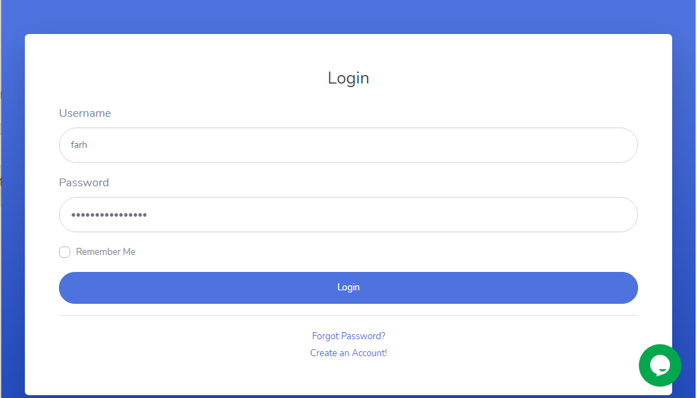

1. Input Halaman Register

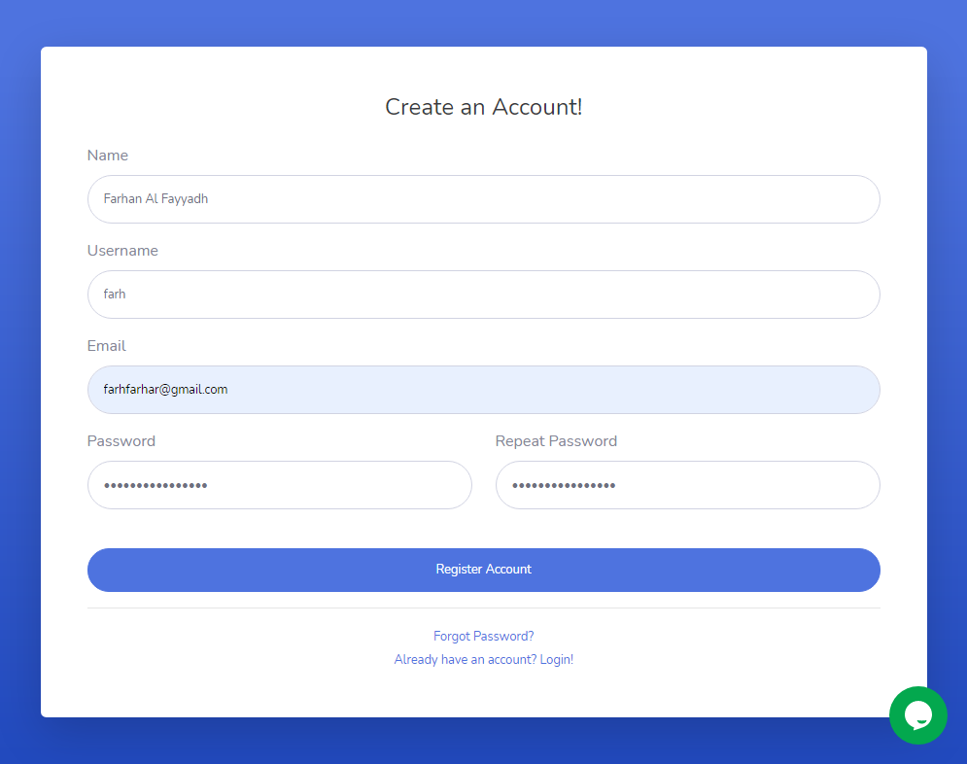

1. Input Halaman Forgot Password

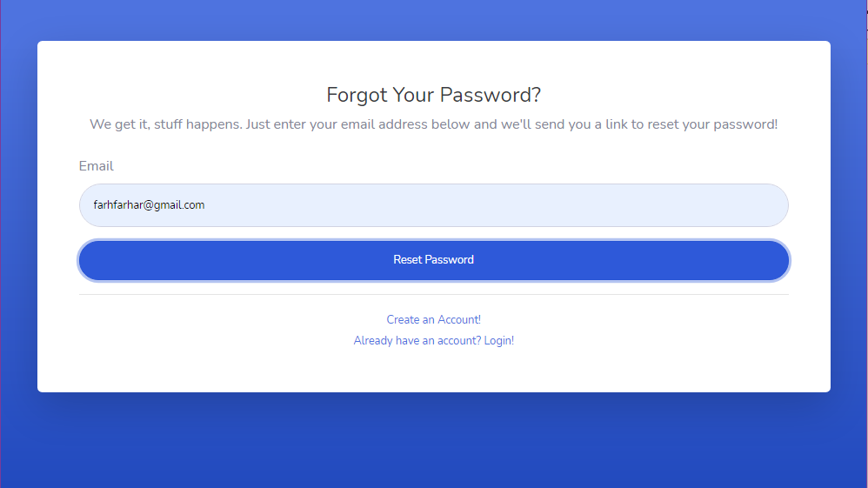

1. Input Halaman Contact

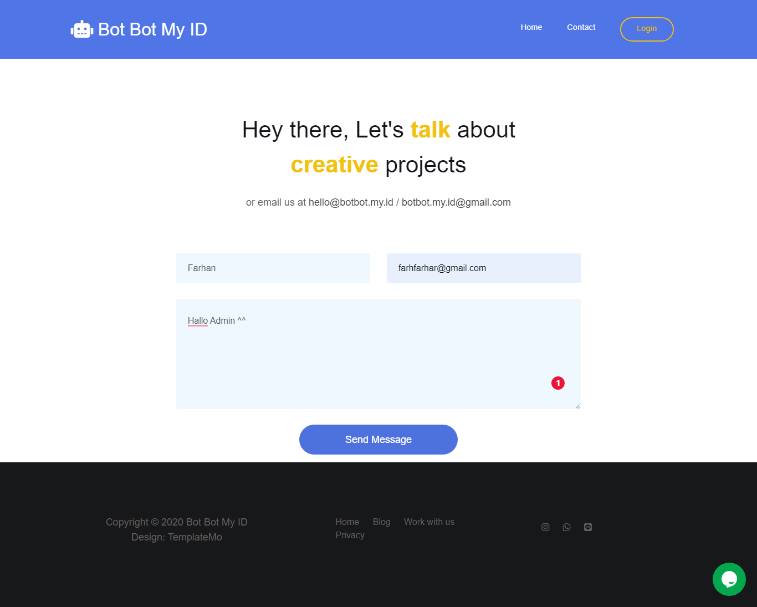

1. Input Halaman Dashboard

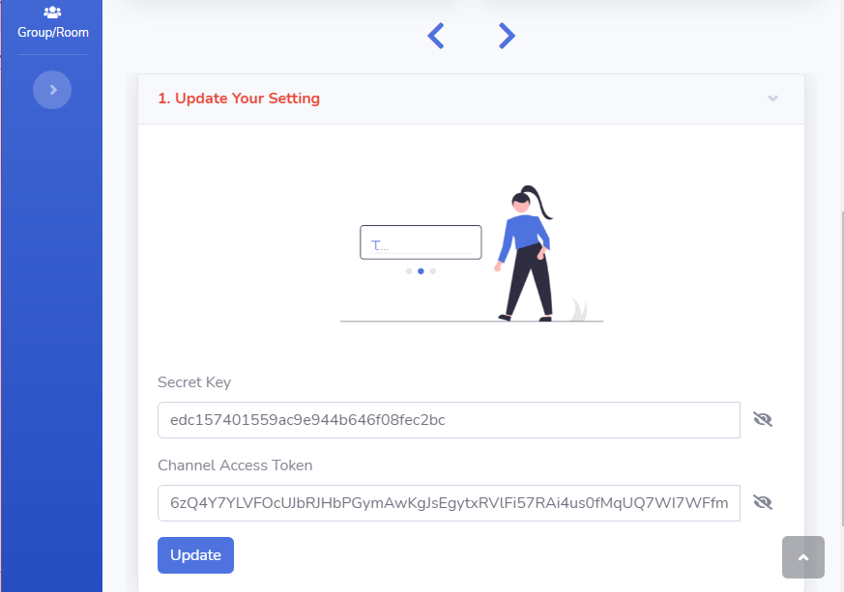

1. Input Halaman Schedule

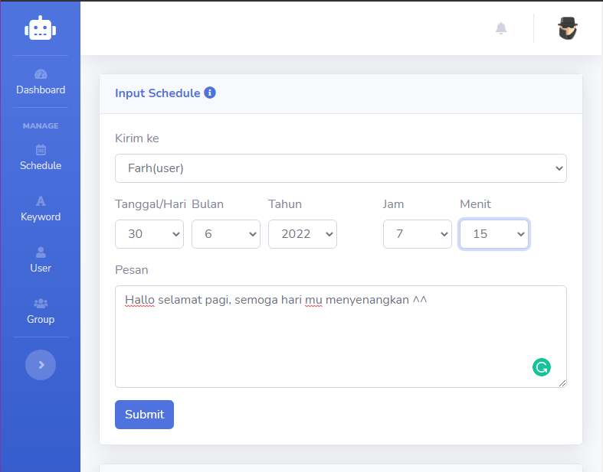

1. Input Halaman Keyword

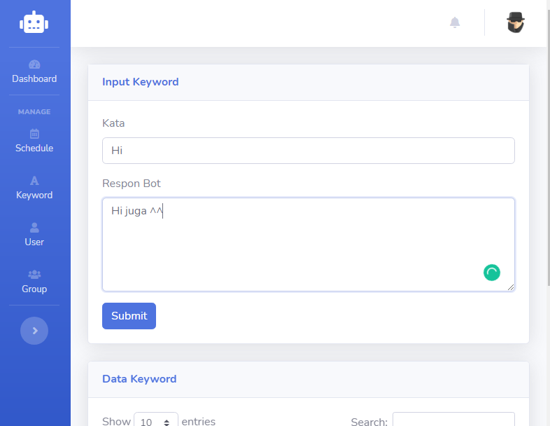

1. Input Halaman User

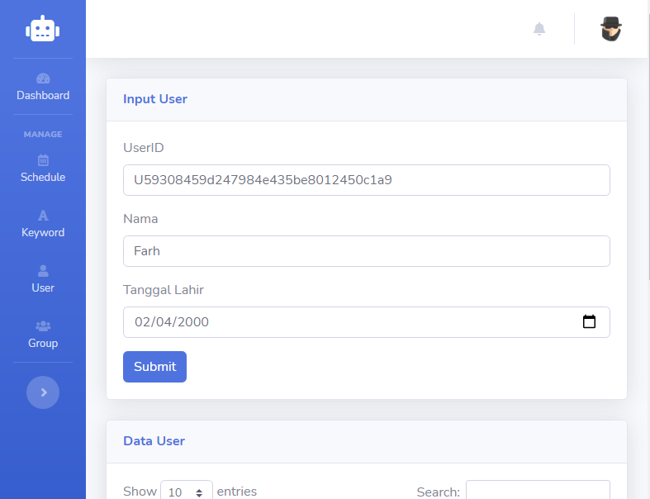

1. Input Halaman Group

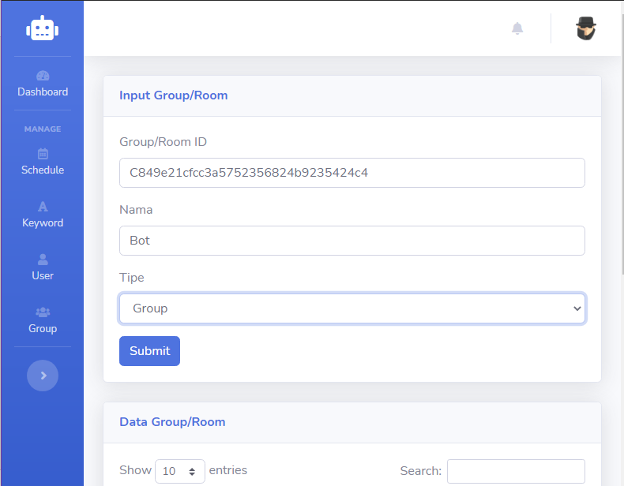

**Lampiran 4 OUTPUT PROGRAM**

# OUTPUT PROGRAM

1. Tampilan Halaman Landing Page

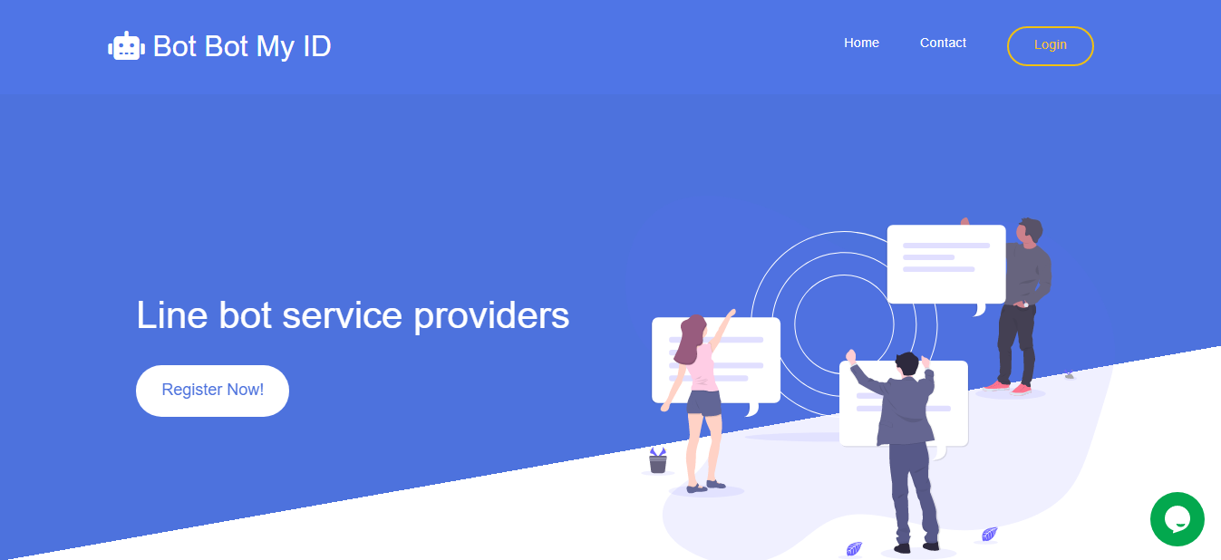

1. Tampilan Halaman Contact

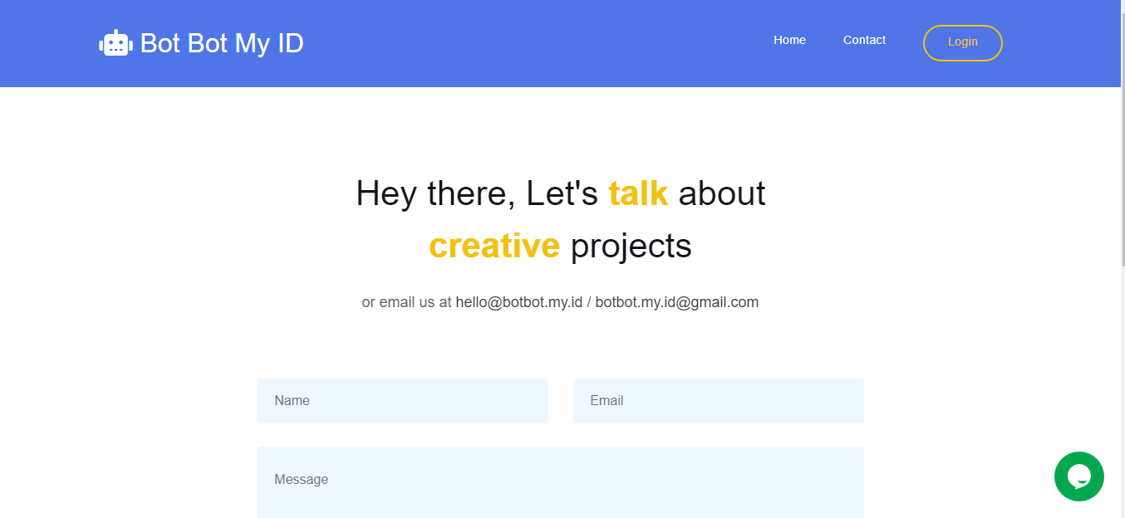

1. Tampilan Halaman Login

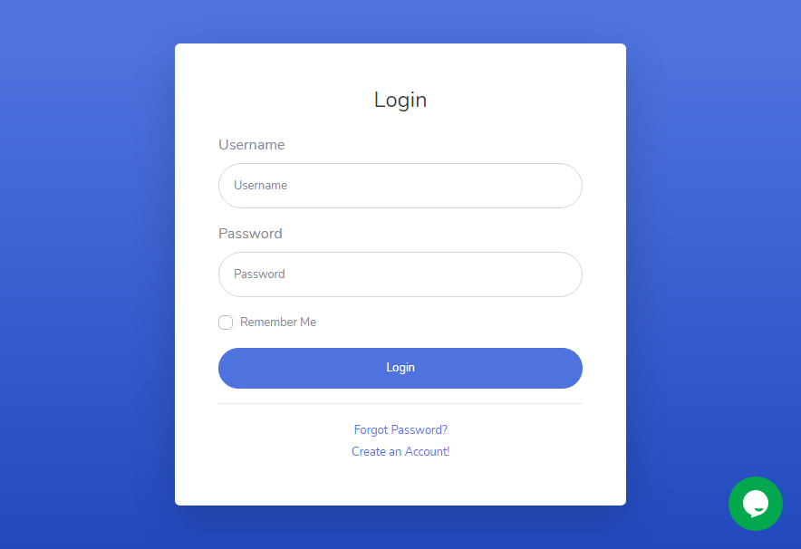

1. Tampilan Halaman Forgot Password

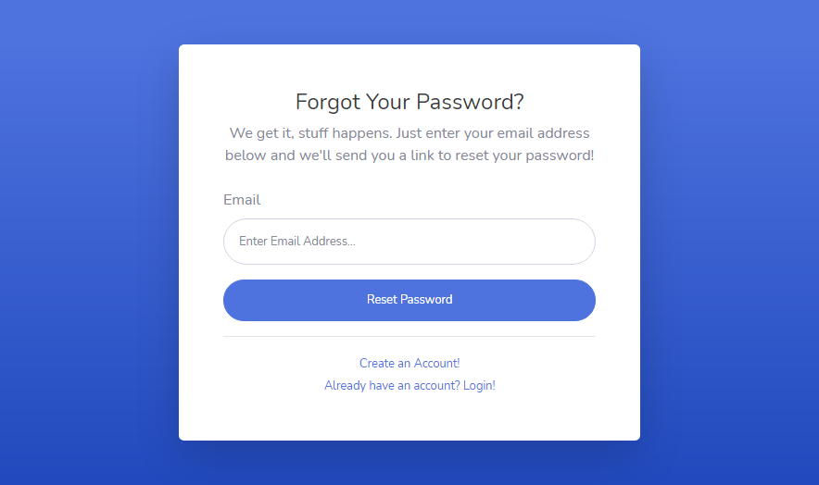

1. Tampilan Halaman Register

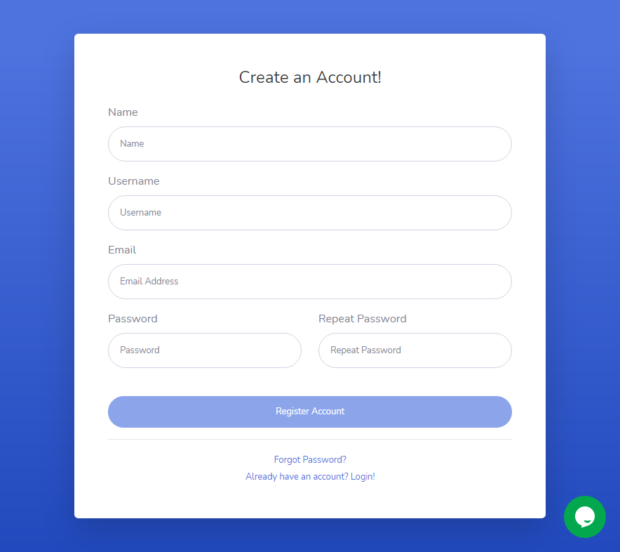

1. Tampilan Halaman Dashboard

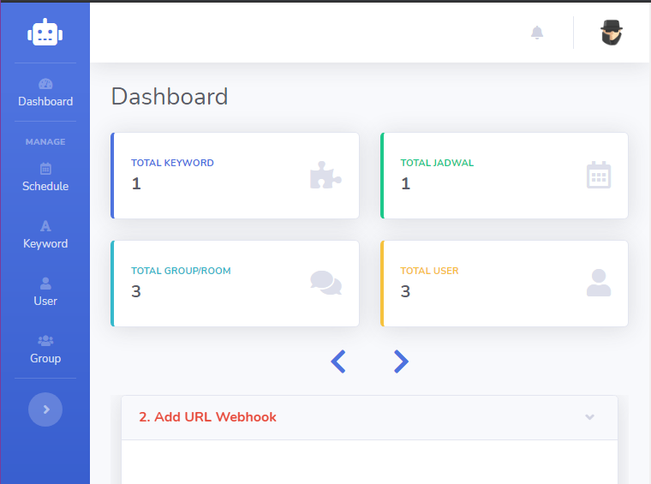

1. Tampilan Halaman Schedule

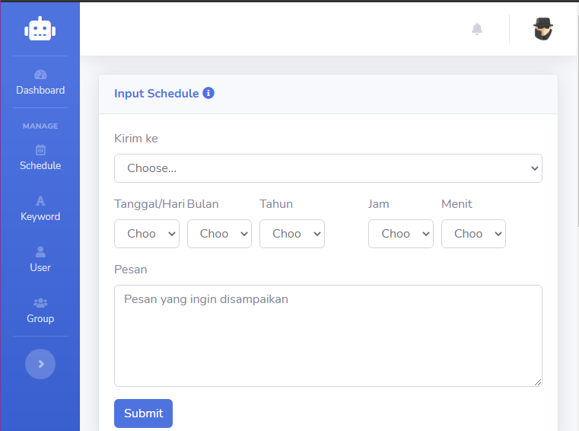

1. Tampilan Halaman Keyword

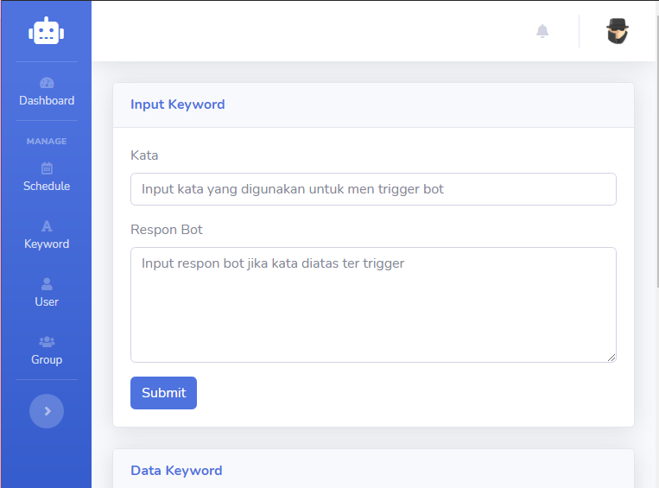

1. Tampilan Halaman User

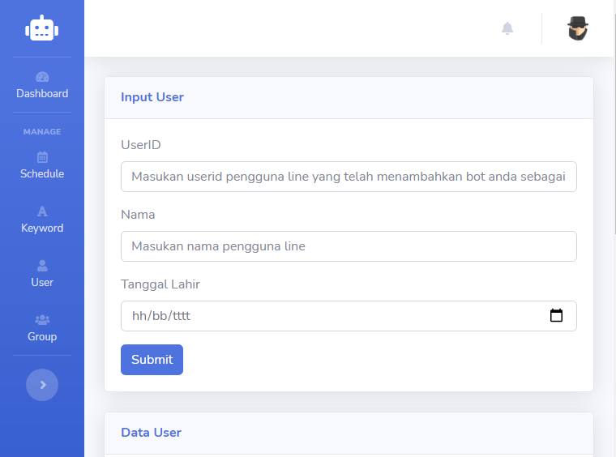

1. Tampilan Halaman Group

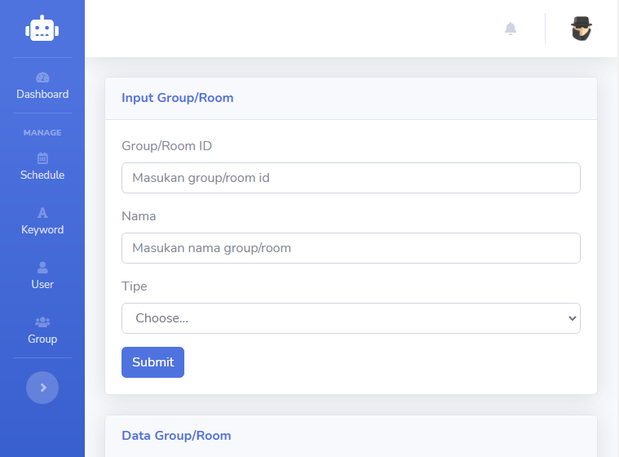

1. Tampilan Halaman Profile

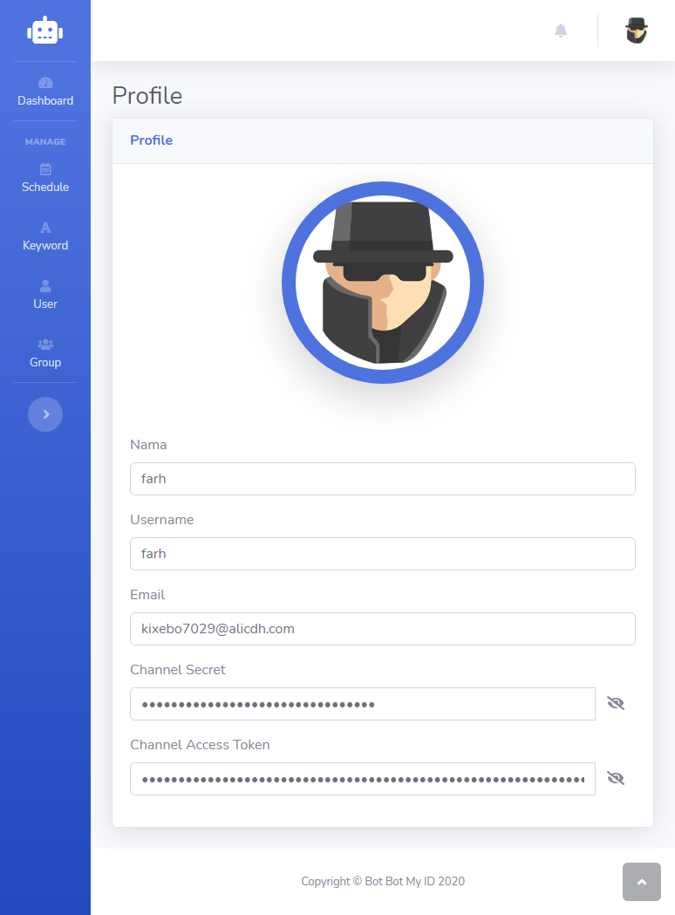

1. Pengujian Pesan Terjadwal

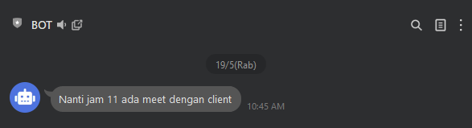

1. Pengujian Keyword

